**Python**

**Functions** parentheses indicate that *print(‘hello world’)* is a function

**New line** \n

**Formatting**

In Python programming, code formatting is crucial. Things like indentation, spaces, tabulation will make a huge difference - and you will soon realise (even the hard way). So, if you're not using an editor of the one listed above, please make sure that your editor can properly setup spacing settings, removing any tab and use 4 spaces as indentation. This is not mandatory for the Python interpreter, but it is the general convention used.

In general, adding blank lines to appropriate places is a good idea. If you are asked to "fix code", feel free to add missing blank lines.

Capitalize names.capitalize() → input will begin from capital letter

Begin with capital letter names.title() → every word will begin from a capital letter

Caps lock names.upper()

Every word begins with a lower letter names.lower()

Like trim in Excel (delete excessive spaces) names.strip()

Underscore in numbers _ → 100_000_000 is 100 000 000. Просто используется, чтобы визуально разбивать число для более понятного визуального восприятия. Число 1_2_3.45 = 123.45.

**Escape character \ (for example \"\" or \'\')**

Use backlash \ to get the double quotation marks around the *The Afterparty* value in the example below:

**Cases**

**Importing modules |** [**Python modules**](https://docs.python.org/3/py-modindex.html) **|**

**Libraries or packages |** [**Packages on Anaconda**](https://anaconda.cloud/package-categories)

[Math](https://docs.python.org/3/library/math.html) import math

[Statistics](https://docs.python.org/3/library/statistics.html#module-statistics) import statistics

[SQLite3](https://docs.python.org/3/library/sqlite3.html#module-sqlite3) import sqlite3

[Time](https://docs.python.org/3/library/time.html#module-time) import time

[Itertools](https://docs.python.org/3/library/itertools.html#module-itertools) import itertools

[Random](https://docs.python.org/3/library/random.html#module-random) import random

[Collections](https://docs.python.org/3/library/collections.html#module-collections) import collections

[Rich](https://github.com/Textualize/rich) Rich is library for rich text and beautiful formatting in the terminal pip install rich from richt import print

[chime](https://github.com/MaxHalford/chime) Sound notifications pip install chim import chime import chime.success() or chime.warning()

[schedule](https://github.com/dbader/schedule) pip install schedule import schedule

Python job scheduling for humans. Run Python functions (or any other callable) periodically using a friendly syntax.

[Faker](https://github.com/joke2k/faker) Generates fake data. pip install Faker import schedule

pandas ([1](https://github.com/pandas-dev/pandas)) import pandas as pd

functools import reduce

[tqdm](https://github.com/tqdm/tqdm) from tqdm import tqdm

warnings import warnings

**Import from a module:**

from math import sqrt as square_root

square_root(144)

>> 12.0

**Help / documentation**

**Use help() to get some information on the function:**

This is also true for your function/class:

**Use help() to get the notes / documentation of a class or a function:**

**Variables**

Line of code. Like *a = 2* is a variable.

Variables can only contain letters, numbers, and underscores (symbol _). Names can start only with a latter or an underscore, not with a number. Spaces are not allowed. Names should be descriptive without being too long: *mc_wheels* is better than *wheels* or *number_of_wheels_on_a_motorcycle*. Name should be the same. E.g. *name* = *name* but *name* != *Name*.

Python keywords that cannot be used as names:

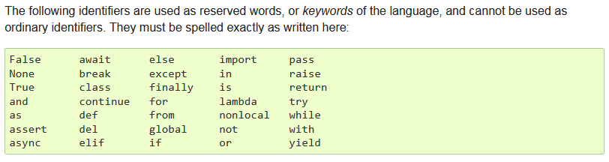

Keywords don’t need parentheses like print().

Be careful about letter l (lowercase) and O (uppercase). They could be confused with 1 and 0.

**Type of data**

**Integer, int** numbers like 2, 3, 40

**Floating-point, float, число с плавающей запятой** numbers like 2.3, 4.32, 54.34

**String (строка букв), str** text like ‘Hello world’ or ‘2’ or ‘2.3’ (numbers in quotation marks)

Strings are contained either like this “double-quoted” or like this ‘single-quoted’.

Quotation inside a string:

Use triple-quote ‘’’ or “”” for preserving formatting between lines:

**Check type of data** type(‘hello world’) → str type(17) → int

Another type of data is None. It is Python’s ‘nothing’ value. It behaves just like any other value, and it's often used as a default value for different kinds of things.

**Booleans**

There are two Boolean values: True and False.

The *equal* symbol = is assigning a = 1 means *a* is set to *1*

Two *equal* symbols == are comparing a == 1 means *check if* a *is equal to* 1 / *does* a *equal* 1

In Python, a single equal sign = is used for assignment, while double equal signs == are used for comparison.

Alternative to *a == 1* is *(a == 1) == True*. However, because of readability simply use *a == 1*.

Empty or blank values are seen as False by Boolean and non-empty values are seen as True:

**PEP 8:**

**Common Python idiom**

This is an example of a common Python idiom that leverages short-circuit evaluation and the truthiness of values:

True and 0 or "Name"

In Python, the and and or operators perform short-circuit evaluation. Here's how it works:

* For the and operator, if the left operand evaluates to False or a falsy value, the expression returns the left operand. Otherwise, it evaluates and returns the right operand. **In my words: it returns a truthy value.**
* For the or operator, if the left operand evaluates to True or a truthy value, the expression returns the left operand. Otherwise, it evaluates and returns the right operand. **It my words: it returns a truthy value.**

In the given code, the expression True and 0 or "Name" is evaluated as follows:

1. True and 0 is evaluated first. Since the left operand (True) is a truthy value, the expression proceeds to evaluate and return the right operand (0).
2. 0 or "Name" is evaluated next. Since the left operand (0) is a falsy value, the expression proceeds to evaluate and return the right operand ("Name").

Therefore, the result of the expression is "Name".

**Examples of data type:**

**LIST = [‘A’, ‘B’]**

A **list (square brackets)** is a collection of items that is stored in a variable (lists are collections of objects). The items should be related in some way, but there are no restrictions on what can be stored in a list.

Naming convention: plural name like *cars*, *dogs*. Each item is then a *car*, a *dog*. This gives you a straightforward way to refer to the entire list (dogs), and to a single item in the list (dog).

Example:

**Example of a list with two coupled variables like Name/Surname** people_list = [("Alex", "De Jong"), ("John", "van Maarten"), ("Louis", "Verbeek")]

Retrieve a value: people[0] → ‘Alice’

Retrieve the last value: people[-1] → ‘Charlie’

Length of a list: len(people) → 3

Update list: people[1] = “John” → people → [“Alice”, “John”, “Charlie”]

Create an empty list: list = []

Convert a string (text) to a list:

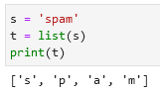 This method breaks a string into individual letters.

If you want to break a string into words use the split method:

To split a string by a delimiter add an optional argument:

**You can also join values in a list using a .join() and a delimiter. Two examples:**

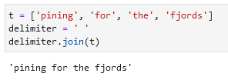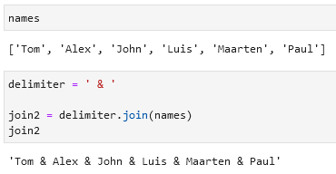

The + operator concatenates lists:

The * operator repeats the list a given number of times:

Add 1 value to a list using .append() or add multiple values as 1 value:

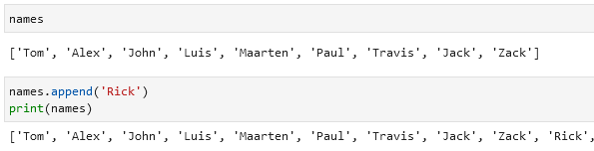

If you want to add multiple values to the list you will need to use .extend():

Delete the last 4 values in the list using del:

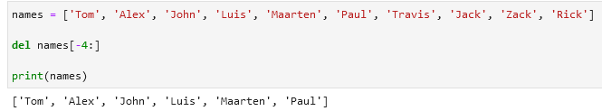

Remove one last item / remove one first item:

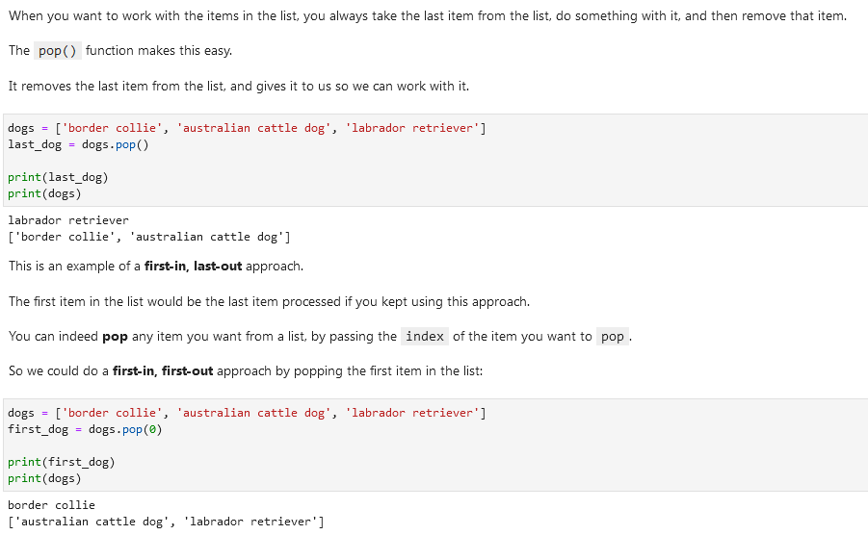

Create a new list with an added value:

**Create a copy of a list:**

In this example:

a = [1, 2, 3]

b = a

a change in a will lead to a change in b.

If you want to create b as a copy of a you shall use the .copy() code:

b = a.copy()

**Sort a list using .sort():**



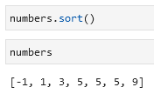

**TUPLE = (‘A’, ‘B’)**

Tuples are basically lists that can never be changed.

Lists are quite dynamic; they can grow as you append and insert items, and they can shrink as you remove items. You can modify any element you want to in a list. Sometimes we like this behavior, but other times we may want to ensure that no user or no part of a program can change a list. That's what tuples are for.

Technically, lists are mutable objects and tuples are immutable objects. Mutable objects can change (think of mutations), and immutable objects can not change.

If you try to change the tuple using e.g. append() you will get an error. The same kind of thing happens when you try to remove something from a tuple, or modify one of its elements. In sum: once you define a tuple, you can be confident that its values will not change.

Tuple unpacking means:

**Update a tuple:**

**SET = {‘A’, ‘B’, ‘C’}**

A set object is an unordered collection of distinct hashable objects. Common uses include membership testing, removing duplicates from a sequence, and computing mathematical operations such as intersection, union, difference, and symmetric difference.

Sets are commonly used when you want to work **with unique elements** and **perform operations like finding intersections, unions, or differences** between sets. They **do not maintain order**, and **duplicate elements are automatically removed**.

**Create a set:**

**Create a set using set():**

set([‘apple’, ‘orange’])

**Operations in sets:**

**Example 1**

**DIFFERENCE -** Find unique values in the first set that are not present in the second:

**SYMMETRIC DIFFERENCE ^** Returns the elements that are unique to each set:

**Example 2**

**Example 3**

**Add values to a set using .add():**

fruits = {'apple', 'banana', 'orange'}

fruits.add('mango')

**Remove values from a set using .remove() or .discard():**

Use .discard() when you want to *avoid an error* while removing a value that is (potentially) not present in your set.

fruits.remove(‘orange’)

fruits.discard(‘tomato’)

Number of values in a set using len():

len(fruits)

3

**Difference between lists, tuples, and sets:**

Lists:

* Ordered collection of elements (i.e. elements have a defined order and can be accessed by their index)
* Mutable (i.e. elements can be added, removed, and modified)
* Can contain duplicate elements
* Defined using square brackets [] or using the list() constructor function

Tuples:

* Ordered collection of elements
* Immutable (i.e. elements cannot be added, removed, or modified once the tuple is created)
* Can contain duplicate elements
* Defined using parentheses () or using the tuple() constructor function

Sets:

* Unordered collection of unique elements (i.e. no duplicates allowed)
* Mutable (i.e. elements can be added and removed)
* Elements are not accessed by index, but rather by value (i.e. you can check if an element is in a set, but you can't access it directly by index)
* Defined using curly braces {} or using the set() constructor function

Some similarities between lists, tuples, and sets:

* Can contain elements of any data type (strings, integers, floats, etc.)
* Can be iterated over using loops
* Can be used in combination with built-in Python functions like len() and sorted()

You would use a list when you need to store an ordered sequence of items that can be changed. For example, a list is useful when you want to keep track of a to-do list or a shopping list, where you may need to add or remove items.

You would use a tuple when you need to store an ordered sequence of items that cannot be changed. For example, a tuple is useful when you want to store the coordinates of a point in two-dimensional space, where the x and y values are fixed.

You would use a set when you need to store a collection of items that are unique and unordered. For example, a set is useful when you want to keep track of a list of unique words in a document, where the order of the words doesn't matter.

Here are some specific examples:

* List: todo_list = ['shower', 'brush teeth', 'mow lawn', 'eat brains']
* Tuple: point = (3, 5)
* Set: unique_words = {'apple', 'banana', 'orange', 'pear'}

Of course, these are just a few examples and there are many other use cases for lists, tuples, and sets depending on the specific problem you are trying to solve.

[] () {}

[] () {}

**Hashable / non-hashable objects**

In Python, a hashable object is an object that can be hashed, meaning it can be used as a key in a dictionary or an element in a set.

Hashable objects must have a hash value that remains the same throughout their lifetime (immutable). This means that if two hashable objects are equal, their hash values must be equal as well.

**Examples of hashable objects** include **integers, floats, strings, and tuples** (as long as their elements are also hashable).

On the other hand, non-hashable objects are objects that cannot be hashed, meaning they cannot be used as keys in a dictionary or elements in a set.

**Examples of non-hashable objects** include **lists, dictionaries, and other mutable objects**, which can change their contents or structure over time.

**DICTIONARY = {‘A’: 1, ‘B’: 2, ‘C’: 3}**

A dictionary is like a list, but more general.

In a list, the indices have to be integers *(numbers)*; in a dictionary they can be (almost) any type.



You can think of a dictionary as a **mapping** *(links)* between a set of indices (which are called keys) and a set of **values**. Each key maps to a value *(links to a value).*



The association of a key and a value is called a **key-value pair** or sometimes an **item**.

A dictionary connects two pieces of information. Those two pieces of information can be any kind of data structure in Python.

Create an empty dictionary: ruseng = {} or ruseng = dict()

What can be stored in a dictionary:

**Retrieve a value from a dictionary using .get().** It will retrieve a value if there is one and will return some text you write. It is useful while looking for values in dictionaries without getting the errors:

We have a *vocab* dictionary:

It gets the value there is (*‘ni’*) and returns *‘Not yet known’* for a value that is absent:

**Add new key-value pair**

Dictionary_name[‘new key name’] = new_value

Add a new key-value pair where the value is equal to a different key:

**Modify a value**

**Remove key-value pair using .pop()**

**Update: .pop() is used to remove the latest item together with selecting it (and not only in dictionaries but also in e.g. lists).**

If you give a name to the .pop line you can select the removed value.

Remove key-value pair using .popitem(). It will remove the last inserted key-value pair & also return it.

**Lists in a dictionary**

**Example 1:**

**Example 2:**

Accessing values in lists:

**Traversing through dictionaries**

**Loop through all key-value pairs** using .items(). This code pulls all key-value pairs from a dictionary into a list of tuples.

Example 2 with list comprehensions:



**Looping through all keys** in a dictionary using .keys() or without it:

Both get the same result. This is because when you iterate over a dictionary using a for loop, it only iterates over the keys by default. In other words, in the line for key, value in my_dict:, the variable key will be assigned to the key of each key-value pair in my_dict, while the variable value will be left unassigned. To fix this error, you need to use the .items() method to iterate over both keys and values of the dictionary.

**Get the value of a specific key:**

Alternative example:

**Looping through all values** in a dictionary using .values():

**Traverse through two lists / iterate through two lists** at the same time using zip():

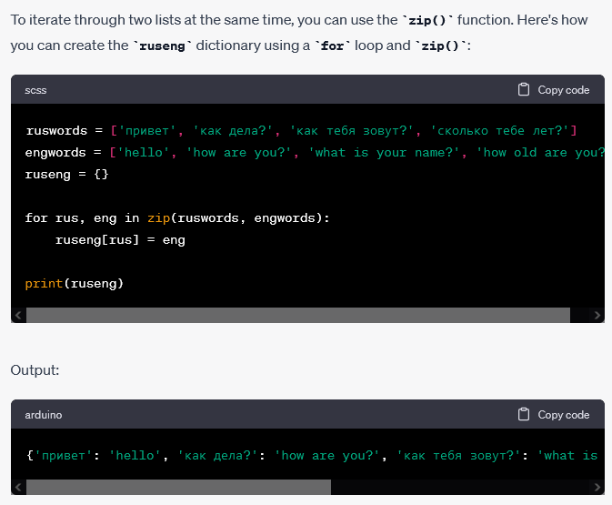

Enumerate through a dictionary / print a dictionary:

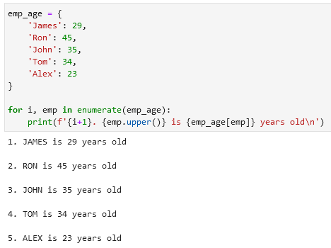

Enumerate through a dictionary with multiple values per key:

**IMPORT statistics**

**Calculate average of a dictionary’s values** using .mean():

**Dictionary within a dictionary**

Print-out a dictionary within a dictionary:

**Note on nesting**

While one level of nesting is really useful, nesting much deeper than that gets really complicated, really quickly. There are other structures such as classes which can be even more useful for modeling information. In addition to this, we can use Python to store information in a database, which is the proper tool for storing deeply nested information.

Often times when you are storing information in a database you will pull a small set of that information out and put it into a dictionary, or a slightly nested structure, and then work with it. But you will rarely, if ever, work with Python data structures nested more than one level deep

**ARRAYS**

In Python, an array is a collection of elements of the same data type, which are stored in contiguous memory locations. Unlike lists, arrays are designed for numerical data and provide more efficient storage and faster access to the elements.

Python provides the array module that allows you to create arrays. To create an array, you need to specify the data type of the elements, and then you can initialize the array with a sequence of values.

Here's an example:

In this example, we create an array of integers using the array module with the type code 'i'. The type code is used to specify the data type of the array elements (in this case, integers). We also initialize the array with a list of values.

We can then access the elements of the array using indexing, change the value of an element using assignment, and iterate over the elements using a for loop.

**CLASSES**

**Object-oriented programming,** or **OOP** for short, focuses on building reusable blocks of code called **classes**. When you want to use a class in one of your programs, you make an object from that class, which is where the phrase "object-oriented" comes from. Python itself is not tied to object-oriented programming, but you will be using objects in most or all of your Python projects.

A **class** is a body of code that defines the attributes and behaviors required to accurately model something you need for your program. You can model something from the real world, such as a rocket ship or a guitar string, or you can model something from a virtual world such as a rocket in a game, or a set of physical laws for a game engine.

An **attribute** is a piece of information. In code, an attribute is just a variable that is part of a class.

A **behavior** is an action that is defined within a class. These are made up of **methods**, which are just functions that are defined for the class.

An **object** is a particular instance of a class. An object has a certain set of values for all of the attributes (variables) in the class. You can have as many objects as you want for any one class.

Classes are a way of combining information and behavior.

Example of a class:

Same with notes:

For example, let's consider what you'd need to do if you were creating a rocket ship in a game, or in a physics simulation. One of the first things you'd want to track are the x and y coordinates of the rocket. Here is what a simple rocket ship class looks like in code:

**FrozenSets**

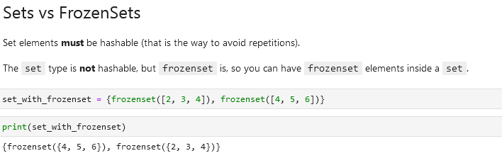

**Named Tuples**

**COLLECTIONS** First you need to *import collections* 

Example 1:

Example 2:

My example:

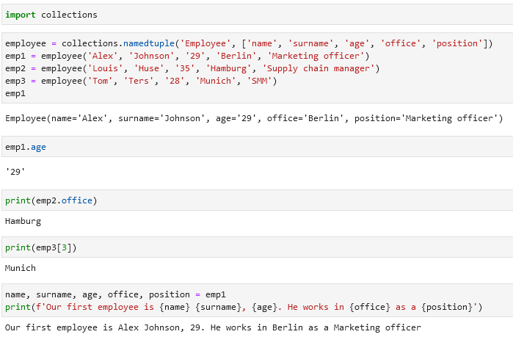

**Deques**

See also *Remove one last item / remove one first item:*

If you want to **add/remove a value** to a list *deques* can be an alternative.

**COLLECTIONS** First you need to *import collections* 

Then you need to transform your list into a *deque*:

Use *appendleft* or *append* to add values at the beginning/end:

If you want to select the first/last value use *popleft()* and *pop():*

These values will be removed from the *deque*. Use *list()* to transform the deque to a list.

**Operators and Operands**

Operators are special symbols that represent computations like addition and multiplication. The values the operator is applied to are called operands.

Operators:

+ addition

- subtraction

* multiplication

/ division

** exponentiation

% [modulo operator](https://www.freecodecamp.org/news/the-python-modulo-operator-what-does-the-symbol-mean-in-python-solved/) used to check if a number is чётный/нечётный (even/uneven number), или для того, чтобы узнать делится ли на какую-то цифру число (например *3* делится на *3*, *5* на *5*, *15* на *15* и так далее). Если делится, то результат будет *0*.

** or *exponentiation* называется по-русски *в степени*. То есть 5 ** 2 это 5^2 или 52 или 5 * 5.

В некоторых других языках символ ^ используется для *степени*, но в питоне это [bitwise operator](https://wiki.python.org/moin/BitwiseOperators) called XOR.

**Comparing operators**

There can also be multiple comparisons.

Examples:

**Order of operations**

**String operations**

There are mostly two: *+* and *\**

More elaborate:

**Floating-point operations**

Could have unexpected results like here:

Don’t worry, this is the way computers represent numbers internally.

More elaborate:

**Commenting and comments**

Use hashtag symbol *#* to leave a comment.

Everything from the # to the end of the line is ignored.

Comments are most useful when they document non-obvious features of the code. It is reasonable to assume that the reader can figure out what the code does; it is much more useful to explain why.

Example:

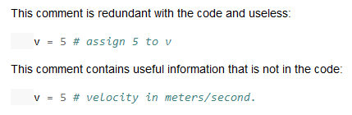

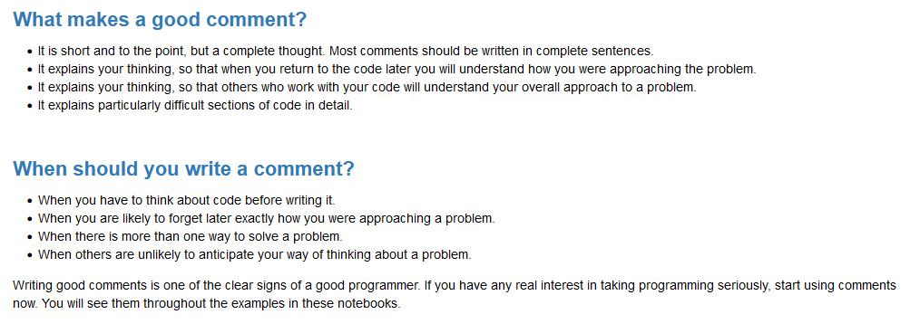

Another way to leave a comment is using “””:

**Functions**

An example of a function is *print()*. If you just execute *print* you will get then <function print> as output.

Functions do something when they are *called* (executed in my words) by typing their names and parentheses. Inside the parentheses, we can pass some arguments too. In *print(‘hello’)* the function is *print* and we give it one argument *‘hello’*.

Sometimes people think that doing func = print('hello') means that Python is going to print hello every time we type func. But this is not correct! print('hello') runs print right away, and if we type func later, it's not going to run print('hello') again.

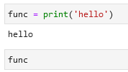

In the context of programming, a function is a named sequence of statements that performs a computation.

When you define a function, you specify the name and the sequence of statements. Later, you can “call” (sometime "invoke") the function by name.

The left side of a function has always to be a name like a = 2 +2, not 2 + 2 = a.

**return statements in a function**

Be consistent in return statements. Either all return statements in a function should return an expression, or none of them should. If any return statement returns an expression, any return statements where no value is returned should explicitly state this as return None, and an explicit return statement should be present at the end of the function (if reachable):

Correct: Wrong:

Я понимаю это так: если ты указываешь *ЕСЛИ должно произойти Х* (в данном случае *число должно быть больше или равно нулю*), то указывай также ЧТО должно произойти, если это не произойдёт. В данном случае или пиши else: return None или return None.

**Example of a function:**

dir() around a (for example) *list* gives an overview of the commands:

**Module**

Python has a *math* module that provides most of the familiar mathematical functions.

A *module* is a Python file that contains a collection of related functions.

To access a function in a module you need to specify the name of the module then dot (also known as a period) then the name of the function. Like *math.log10()*. This format is called dot notation (запись через точку).

**Function annotations**

You can attach metadate to the parameters of a function declaration and its return value.

Example:

Use .__annotations__ to access function annotations:

Use .__doc__ to see function comments:

* Each argument in the function declaration may have an annotation expression preceded by :.
* If there is a *default value*, the annotation goes between the argument name and the = sign.
* To annotate the return value, add -> and another expression between the ) and the : at the tail of the function declaration.

The expressions may be of any type. The most common types used in annotations are classes, like str or int, or strings, like 'int > 0'.

**Python functions**

**print()**

**input()**

Use input() to get start a input line to get some input from the user.

Example: After typing in my name:

If you assign the input() function to a *name* like in the example above my_name, you will get the *value* you got from the input while running the function:

**round()**

**ord()**

Given a string representing one Unicode character, return an integer representing the Unicode code point of that character. For example, ord('a') returns the integer 97 and ord('€') (Euro sign) returns 8364. Inverse of chr().

**__main__ function**

Своими словами: ты написал 2 функции и ещё последнюю функцию назвал main, которая сводит первые две функции в одну. Если ты хочешь чтобы твоя третья функция main сразу же была активизирована, то ты пишешь в конце if __name_ и так далее. Пример из Chart GPT:

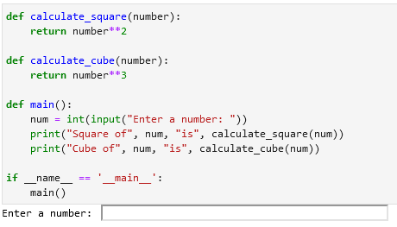

Альтернативой может быть просто main(), но тогда:

**from math module functions**

from math import sqrt

Math.log() compute logarithms

Math.sin() get the sinus, also .cos, .tan etc.

Math.pi gets the π value / pi value

Math.sqrt() get the square root of a number like math.sqrt(16) = 4.0

Math.exp ?

Math.hypot(x, y) Calculates the Euclidean norm (length of a vector with two components). Takes two numeric arguments and returns the square root of their sum of squares: x2 + y2.

**from random module functions**

from random import randint

randint() generate a random number between 0 and 10: randint(0, 10)

**zip()**

The zip() function takes multiple iterables as arguments and returns an iterator that generates tuples containing elements from each iterable. Each tuple in the resulting iterator represents a pair of corresponding elements from the input iterables.

In other words: it takes your input and creates a tuple of lists where the first list has only the first values, the second only the second values etc. It will be as long as the shortest value in your input.

Example 1: Example 2:

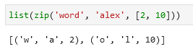

**Higher-order functions**

Sort a list of words by its length (**sorted(),** **map()**):

**map() map(function, iterable)**

Iterate over an iterable (e.g. a list, tuple, string) using a function provided. In the example below iterate over list *numbers* using the *square* function:

**Note:** **map() returns an object and not a list**. That is why you need to **convert it to a list using the list()** function.

**for loop or map()**

The same is achieved by the following two examples below. However, the second example with the map() function is more concise and can be considered as a shorter and sometimes more efficient alternative to the first example with the for loop.

**lambda expression**

One way to write small functions is to use the lambda expression. lambda takes a number of parameters and an expression combining these parameters, and creates an anonymous function that returns the value of the expression:

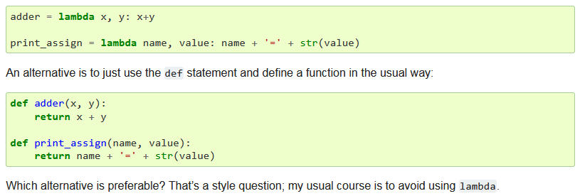

From here <https://docs.python.org/3/howto/functional.html>

**Converting data / data conversion / datatype conversion / change data type**

Change data to integer (to int) int(‘32’) → 32

won’t work on *int(‘dadw’)*

*int(2.99) → 2* it will drop the part after the point (here .99)

Convert data to float float(3) → 3.0 float(‘3.2342’) → 3.2342

Convert data to string (to str) str(32) → ‘32’

**If-statements**

There two are the same:

However the second is better since by default python considers blank values as false. So we can say that if message is not blank then print what was entered, otherwise print that you did not enter anything. Check the Boolean section for more info.

Same code (last is the best):

Another example:

Make a space between two values:

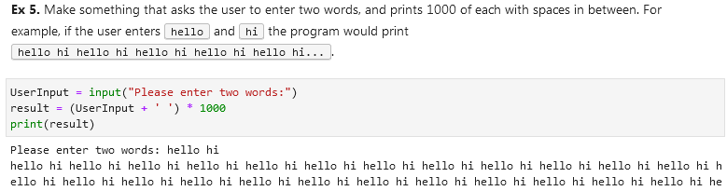

A statement should be equal to null (should be blank):

**Function definition / define a function**

Function example:

Function example:

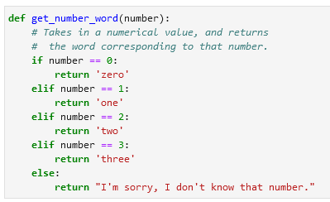

Function example:

**Setting a default value in a function.** In this case the default value is *‘everyone’:*

If you have multiple arguments like def thank_you(name, surname) you don’t need to input your arguments like thank_you(‘John’, ‘Smit’). This will also work: thank_you(surname=’Smit’, name=’John’). By keywording arguments you can place them in arbitrary order.



**Assigning two or more names to a tuple / extracting two or more variables from a tuple:**

1. If we have a list of elements the first and last variables will always select first and last elements. E.g. if we have 10 elements and 2 variables we will only select first and last element.

2. If I add extra variables between these (first and last) variables I will only select 2nd, 3rd etc. elements, but I other elements (e.g. from 4 to 9) will not be selected.

3. If I want to assign all other elements e.g. from 2 to 9 to a variable I need to add an asterisk before that variable.

4. Asterisk should be before that variable without any spaces.

Example:



a = 1

c = [2, 3, 4]

b = 5

**VSCode executing code**

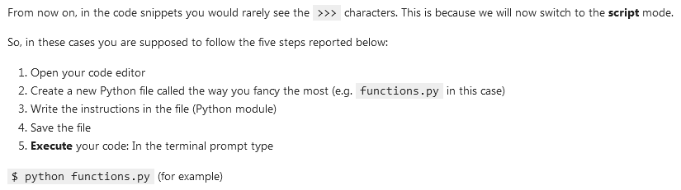

**Sequences**

* **Container sequences** can hold items of different types. They hold reference to the objects they contain, which may be of any type. Examples:
  + list
  + tuple
  + collections.deque
* **Flat sequences** hold items of one type. They physically store the value of each item within its own memory space, and not as distinct objects. They are more compact, but are limited to holding primitive values like characters, bytes, and numbers. Examples:
  + str
  + bytes
  + bytearray
  + memoryview
  + array.array

Another way of grouping sequence types is **mutability**:

* **Mutable** sequences:
  + list
  + bytearray
  + array.array
  + collections.deque
  + memoryview
* **Immutable** sequences:
  + tuple
  + str
  + bytes

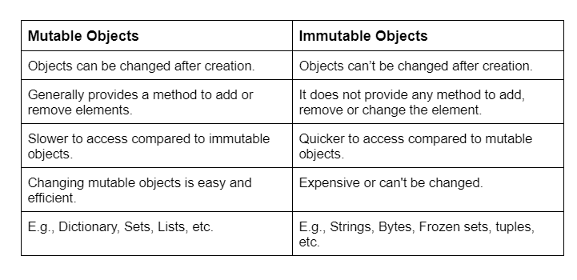

**for loop / for iteration loop / iterations / traversing**

This most widely used iteration mechanism in Python. Every sequence can be iterated (element by element). Also while loops are permitted, but the *for* loop is the one you’ll see and use most of the time. Strings and lists are iterable, but integers and floats are not

Example:

Printing out names from the list called *names:*



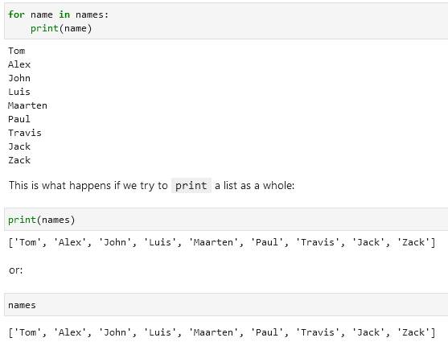

Example of a *for* loop that prints out people’s names using a function *greeter:*

*for* *arbitrary name of the variables in the list* *in* *name of the list*:

*function name*(*arbitrary name of the variables in the list*)

Example of a for loop with two or more variables:



**break and continue statements / keywords in a for loop:**

The example below illustrates the break statement in an *infinite loop*. The loop is running until the input is either *yes* or *y*. Then the loop is stopped using the break statement at the end.

Example 1:

Other examples:

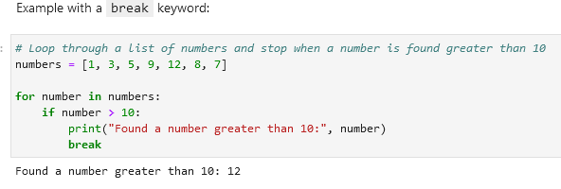

**Enumerate a loop:**

Instead of *for dog in dogs* you add *for index, dog* and you add *enumerate(dogs):*

The value in the variable index (i) is always an integer (number). If you want to print it in a string turn the integer into a string like here:

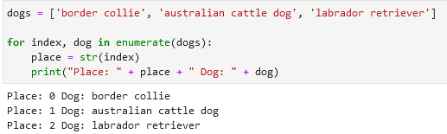

Another example for **enumerating in a pair**:

**Manually iterating**

Use .__next__() to iterate manually:

Alternative function that does the same thing is next():

**Iter() iteration**

There's a built-in function called iter() that converts anything iterable to an iterator.

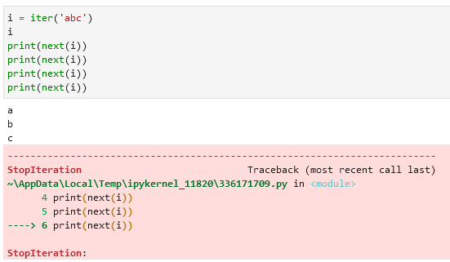

Iterating using iter(): Alternative:

**Retrieve a specific part of e.g. a list:**

Make use of an additional row captures only the needed rows. In this case it is the *first_batch = usernames[0:3]* row that selects only the first 3 items in the list:

**Examples of iterators**

enumerate(iterable)

range(start, end, step)

dictionary.keys()

dictionary.values()

dictionary.items()

Example of a .range():

**while loops**

while loops are used when you want to repeatedly execute a block of code as long as a certain condition is true.

Basic structure of a while loop:

The loop starts by evaluating the condition. If the condition is true, the code inside the loop is executed. Afterward, the condition is checked again, and if it is still true, the code is executed again. This process continues until the condition becomes false. Once the condition is false, the loop is exited, and the program continues with the next line of code after the loop.

**Example 1: Example 2:**

**Example 3** (empty list [], .randrange(), .append())**:**

**Functions**

range() range(start, end, step) Generates a list of numbers between *start* and *end* with a given *step:* **range(0, 20, 2)**

The last value will not be included.

**Check if data exists in your list/tuple/set:**

**IMPORT statistics**

Calculate average of a dictionary’s values using .mean():

|  |  |
| --- | --- |
| **Easter egg** | Import this |
| **Import pandas** | import pandas as pd |
| **Import NumPy** | import numpy as np |
| **Series (a column)** | pd.Series([21, 22, 23, 24], name = ‘age’)  *age = column name* |
| **Select an element (row; from 0 to …)** | table_name[3]  *Select the 4th row* |
| **Make a custom axis to a Series** |  |
|  |  |
| **Index** is also called an **axis**; each element is called axis label.  Data in columns is called as **values**.  A series ideally should have the same datatype throughout its values (same format for the whole column). |  |
| **Dataframe** | A series is a column and a dataframe has multiple columns |
| **Create a dataframe** |  |
| **Columns and rows in a dataframe (table)** | df.shape  (3, 7)  3 rows and 7 columns |
| **Axis 0**  **Axis 1** | Vertical axis (rows)  Horizontal axis (column names) |
| **Select a column** | df[‘ADDRESS’]  Returns a series |
| **Select several columns** | df[[‘ADDRESS’, ‘CITY’]] |
| **Retrieve axis 1 / column names / information** | df.columns  Index([‘first_name’, ‘last_name’, ‘email’], dtype=‘object’) |
| **Retrieve axis 0 / vertical axis information** | df.index  RangeIndex(start=0, stop=3, step=1) or min 0, max 3 (3 rows) |
| **Retrieve a row** |  |
| **Make a column as an index** | E.g. you want to filter by last name. Instead of the default 0, 1, 2 etc. you can make the index as Nield, Scala Morrison.  *df.set_index(‘column_name’, inplace = True*) inplace is true so it edits the existing df instead of creating a new one  *df.loc[‘Scala’]* you can now use the last name to search for this row  **df.reset_index(inplace = True)** reset the axis to default |
| **Copy a dataframe** | df2 = df.copy() |
| **New line \n** | Print(‘line1 \nline2’) |
| **Tab \t** | Print(‘line1 \tline2’) |
| **Raw string** | If you don’t want Python to see *\n* as code but part of the text (part of the string) then add an *r* add the beginning of the code.  Print(r’line1 \nline2’)  Output will not be  line 1  line 2  But line1 \nline2 |
| **Check the index of a value** | df = [ 1, 2, 3, 4]  df.index(2)  1 |
|  |  |

**Importing Data**

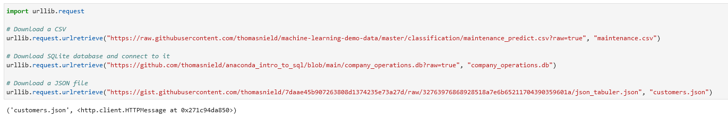

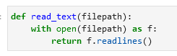

[**Import CSV / read csv / load csv**](https://pandas.pydata.org/docs/reference/api/pandas.read_csv.html)

Read csv as text:

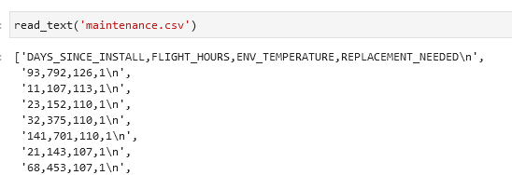

Read csv into as a pandas dataframe:

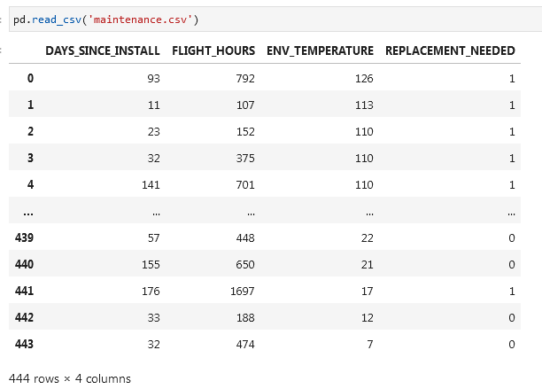

**Read csv alternative:**

df = pd.read_csv('https://raw.githubusercontent.com/thomasnield/machine-learning-demo-data/master/regression/winequality-red.csv')

df

**With *header* and *names*:**

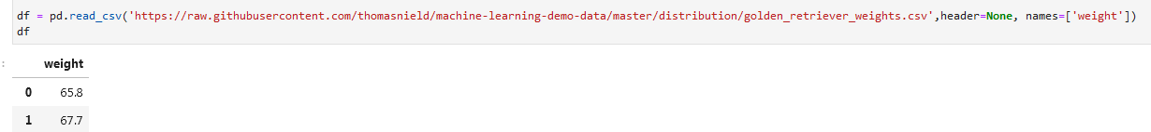

**Alternative:**

Import pandas as pd

url = 'https://raw.githubusercontent.com/thomasnield/machine-learning-demo-data/master/timeseries/datetime_formatting.csv'

df = pd.read_csv(url)

df

**Format dates columns as dates while importing csv:**

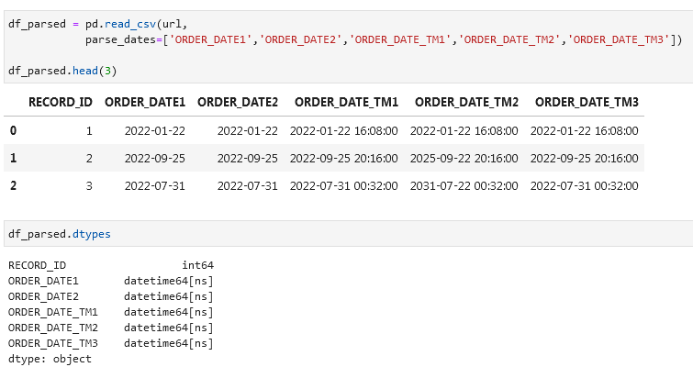

**SQL** [**pd.read_sql**](https://pandas.pydata.org/docs/reference/api/pandas.read_sql.html)

Import an SQL database:

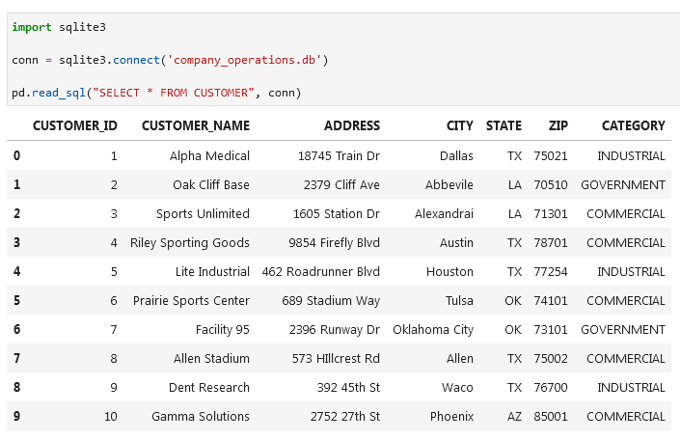

Alternative:

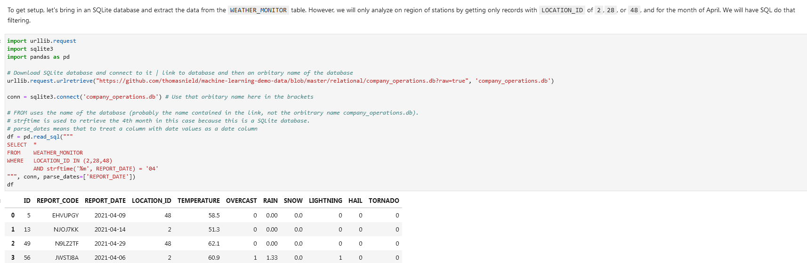

If you don’t *parse_dates*:

With parsing and without:

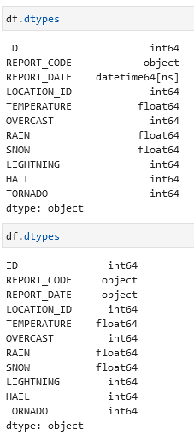

**JSON**

Read a JSON file:

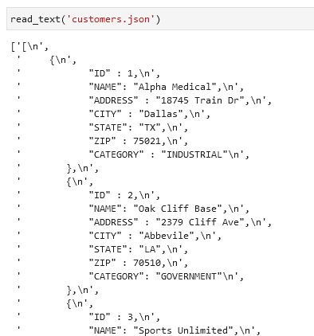

Read a JSON file as a pandas dataframe:

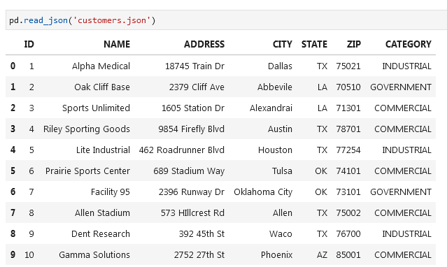

**Selecting Rows and Columns**

**loc and iloc**

* **loc** works on **labels** assigned to the axis, **iloc** works on **numbers**.
* E.g. if axis is surname then **loc** will work only on the surname like ‘**vanli’** while **iloc** will only work on **numbers**.

**Select** (first two) **rows** df.iloc[0:2] or df.iloc[:2]

**Exclude first row** df.iloc[1:]

**Select all** df.iloc[:]

**All rows and columns 2-3** df.iloc[:, 1:3] you are selecting columns 2 and 3 with indexes 1 and 2

**Select last two columns** df.iloc[:, -2:] count from 0 to -1, -2 etc. from right to left. Select the column you want to have and with : you will select everything to the right

**Select the last row** df.iloc[-1]

**Select all rows and last column** df.iloc[:, -1]

**Select all rows and all columns except for the last column** df.iloc[:, :-1]

**Select all rows and reverse them** df2 = df1[::-1]

If you want to get the first 2 rows you need to select the third index, in this case 2:

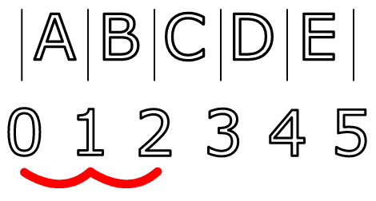

**Select specific columns and rows**. In this case you will select column index 0 and column index 2 (first_name and email). In the second query you will select second row and third column

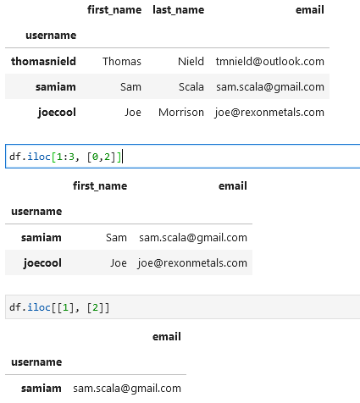

**Select rows and columns using loc** df.loc[["samiam","thomasnield"], "email"]

**Reset index** df.reset_index(inplace = True)

**Select values that start with a specific letter** condition = df["username"].str.startswith("s") username = column, s = letter start

df[condition]

**Multiple conditions. AND & OR are & and |** condition = df["username"].str.startswith("s") & df["email"].str.contains("gmail")

df[condition]

**Get gata in a column that equals to a value** df[df[‘column’].eq(‘value’)] *(filter data to a value)*

[**at and iat**](https://pandas.pydata.org/docs/reference/api/pandas.DataFrame.iat.html)

Similar to loc and iloc there is also an *at* and *iat*. These return a single value at a specific row and column index using numeric or labelled indices respectively.

**Drop columns and rows**

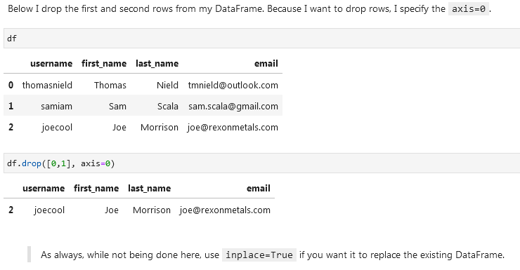

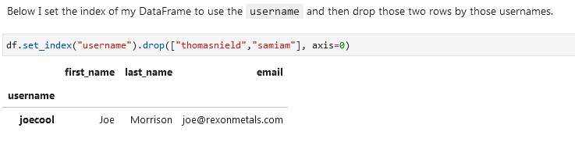

**Remove columns:**



**Remove columns by selecting specific columns like column 1 and 4:**

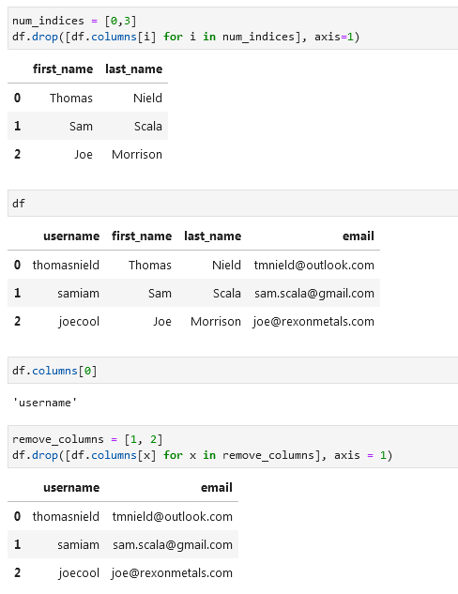

**Adding rows and columns (appending) / Joining concatting**

**Add a column at the end of the dataframe:**

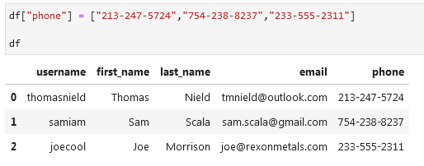

**Add a column at a specific place:**

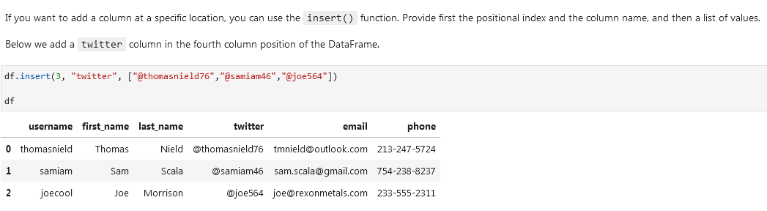

**Add a row:**

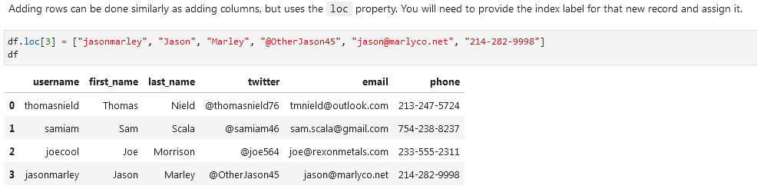

**Using concat (merge two datasets):**

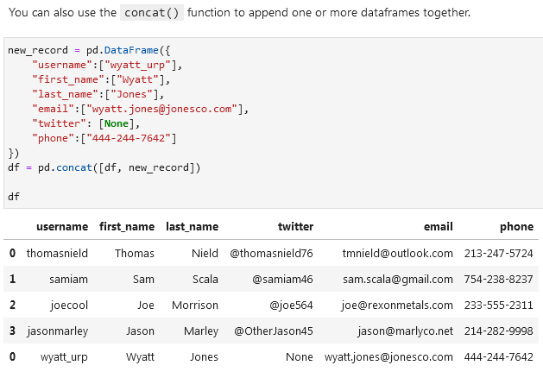

**Merge two datasets using .concat()** In the example below the first *df* is the first dataset and *df.loc[0:2,:]* is the second.

**Updating data**

**Making a column in caps lock (upper):**

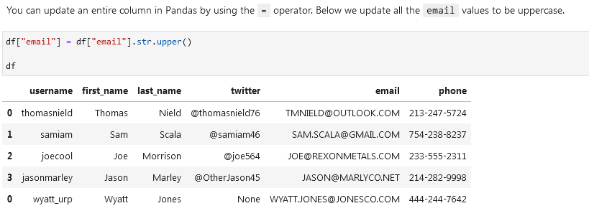

**Updating on a condition:**

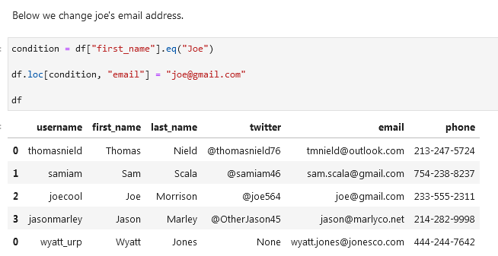

**Update row on condition:**

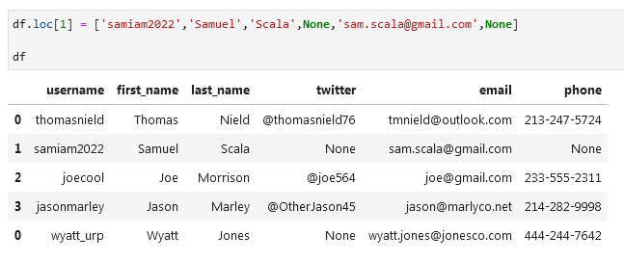

**Unpivoting data (melting):**

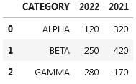

Id_vars = untouched columns

Value_vars = columns that will be unpivoted

Var_name = column names will be moved to this column

Value_name = column values will be moved to this column

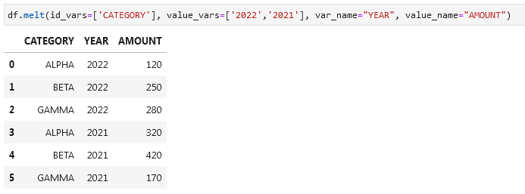

**Sorting, Casting, and Categories**

**Datatypes:**



**Timestamp example (date)** pd.Timestamp(‘20230130’) → 2023-01-30

**Difference between days** pd.Timestamp('20230130') - pd.Timestamp('20230127') → 3 days

**View datatypes** df.dtypes

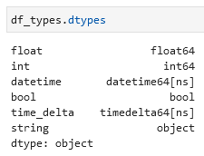

You will get column name on the left (float, int, datatime etc.) and datatype on the right.

**Change a column to a different datatype** df[‘columnname’] = df[‘columnaname’].astype(‘bool’)

**Sort by 2 columns (first lightning, then rain inches)** df.sort_values(by=["lightning","rain_inches"])

df.sort_values(by=["lightning","rain_inches"],ascending=[False,True])

df.sort_values(axis=0, ascending = True) *ascending if one value*

When using the sort methods, remember to **add the inplace=True parameter if you want to replace the existing dataframe** with the sorted one.

Sort by an row index or columns index df.sort_index(axis = 0) for rows

df.sort_index(axis = 1) for columns

**Replace a column with a *category* datatype:**

cat_type = pd.CategoricalDtype(categories=["CLEAR", "MINOR", "MAJOR", "SEVERE"], ordered=True)

df["severity"] = df["severity"].astype(cat_type) severity = column you want to replace

df.sort_values(by=["severity"])

If you apply a categorization on a column that has values not mapping to any category, then those will become NA values.

**Python if/elif/else category function:**

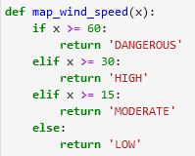

**Apply this function to the wind_speed_mph column:**

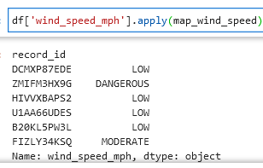

**Add a new column:**

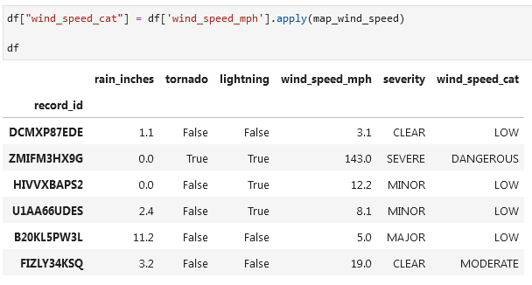

Categorize the last column and sort the data by that column in DESC:

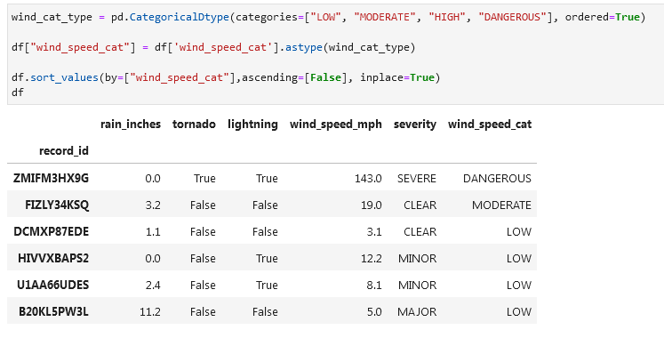

**Removing Duplicative and Sparse Data**

**df used:**

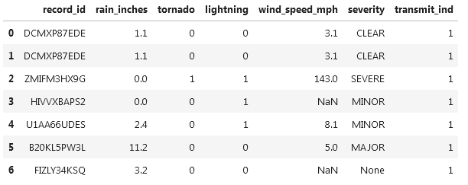

**Get duplicated rows using .duplicated() function:**  df.duplicated()

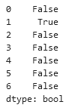

It will mark rows that are duplicates.

If you want to see original rows and their duplicates (like in Excel) then add (keep=False):

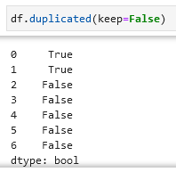

**Look for duplicates in a specific column using *subset*:**

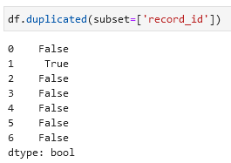

Or if you want to use multiple columns:

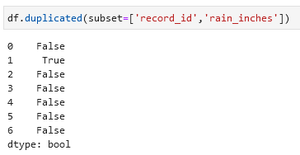

**Delete duplicates** df.drop_duplicates(inplace=True)

**Delete duplicates based on a column** df.drop_duplicates(subset=['record_id'], inplace=True)

Number of unique values in a column df.nunique()

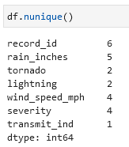

**Identify columns with single-values (e.g. value Shop in the whole column):**

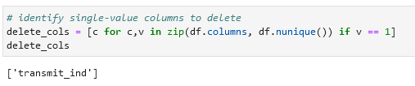

**Drop these columns:** df.drop(delete_cols, axis=1, inplace=True)

**Read csv file (open csv file) (using a link):**

wine_df = pd.read_csv('https://raw.githubusercontent.com/thomasnield/machine-learning-demo-data/master/regression/winequality-red.csv')

wine_df

**Get number of rows and columns from .shape function:**

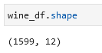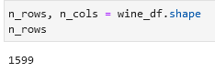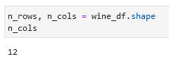

**Alternatively. Get number of rows ([0]) and columns ([1]) from the .shape function (where X = df):**

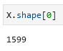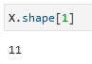

**Count the number of unique values per column:**

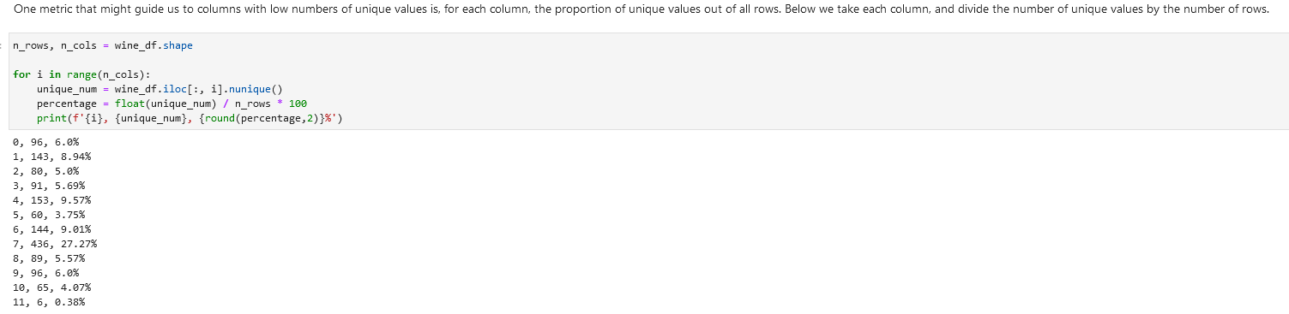

**Remove columns with 5% or less unique values:**

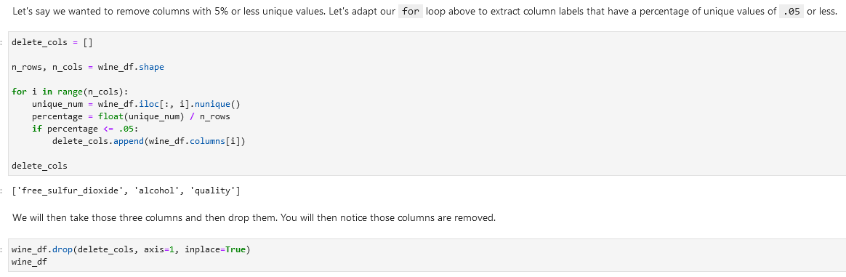

**Alternative using scikit-learn, VarianceThreshold and fit_transform():**

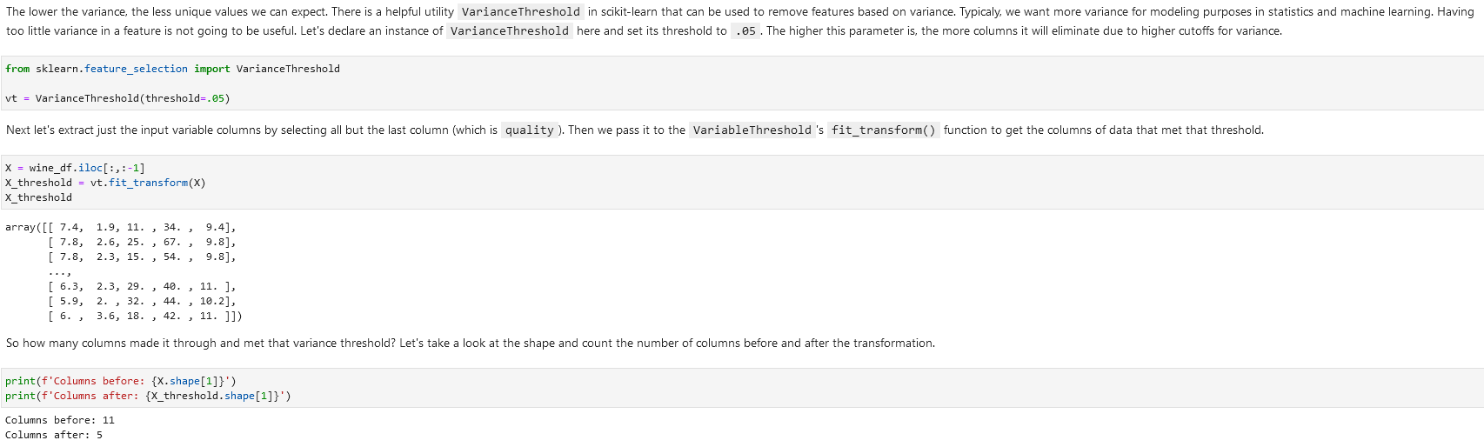

Return from ndarray to get the columns using get_support:

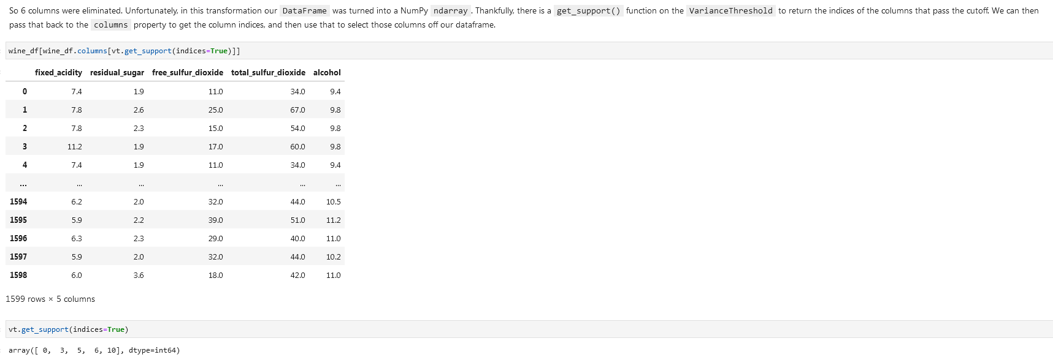

**Remove columns with duplicates and 3 or less unique values:**

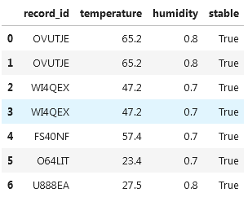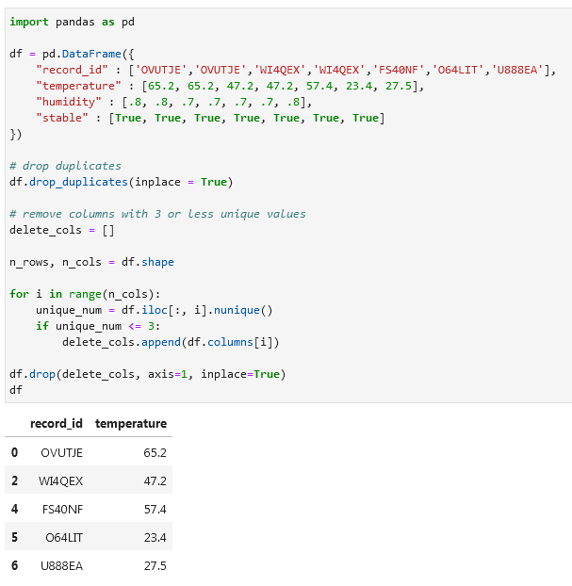

**f-string / f’’ / f”” / printing with f / print(f:**

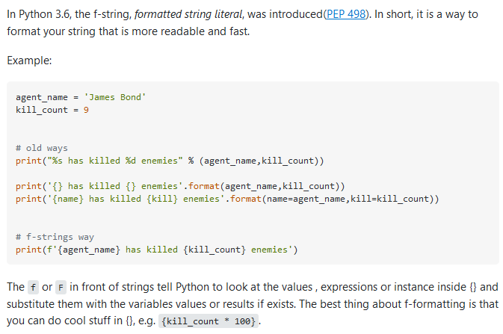

Example

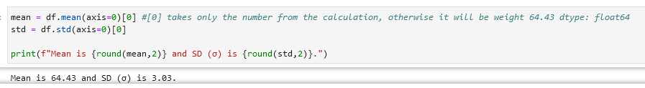

**Before f’’:**

You can use f’’ like here:

**Or you can use %s / %d / %f / %r:**

%s is used as a placeholder for the value of name.title(), which is a string. When the print() statement is executed, Python replaces the %s placeholder with the value of name.title(), resulting in a string like "Eric's favorite numbers are:" or "Willie's favorite numbers are:".

The %s is just one of many string formatting operators available in Python, and is used specifically to insert **string** values into a string. Other operators include %d for inserting **integer** values, %f for inserting **floating**-point values, and %r for inserting **any Python** object as a string representation. In Python 3.6 and later versions, a new string formatting method was introduced using f-strings, which offer a more concise and readable way to format strings.

**Handling missing data**

**Looking for missing values**

**Looking for missing values per row** df.isna() *not efficient in my opinion, alternatives:* df.notna(), df.isnull(), df.notnull()

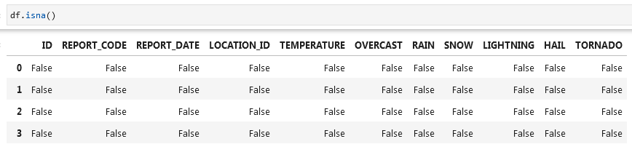

**Check columns for missing values** df.isna().any() *or you can specify axis*  any(axis=0)

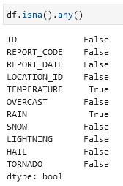

**Check rows for missing values** df.isna().any(axis = 1)

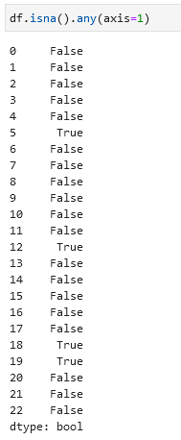

**Select (show) columns with NaN (null) values** df.loc[:, df.isna().any()]

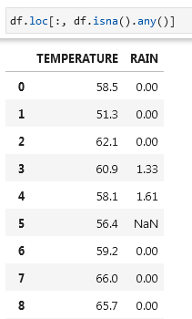

**Select (show) rows with NaN (null) values** df.loc[df.isna().any(axis=1), :] *or* df.loc[df.isna().any(axis=1)]

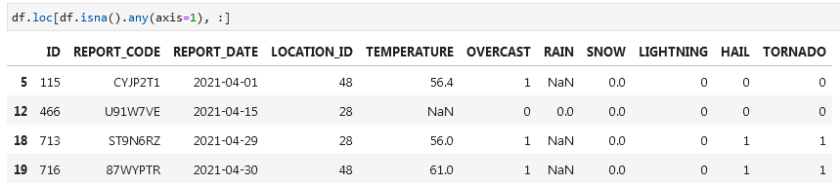

**Look for missing values in specific columns** df[df['TEMPERATURE'].isna() | df['RAIN'].isna()]

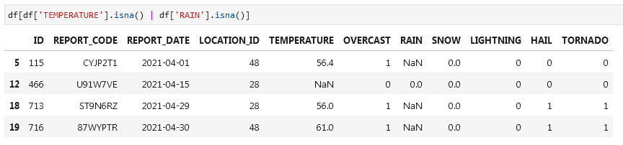

**Removing rows with missing values**

Note: many ML and statistical models do not tolerate NA, NaN or other missing null values.

**Remove rows with missing values / drop rows with missing values** df.dropna(axis=0, inplace=True)

**Remove rows with missing values in specific column** df.dropna(axis=0, subset=["RAIN"], inplace=True)

**Remove rows with missing values in specific columns** df.dropna(axis=0, subset=[“TEMPERATURE”, "RAIN"], inplace=True)

**Remove columns with missing values / drop columns with missing values** df.dropna(axis=1, inplace=True)

**Replacing missing values**

**Replace missing values with -1** df.fillna(value=-1, inplace=True)

You can’t specify a column using the subset parameter. To target specific columns you will need to extract them out and then apply fillna().

**NUMPY Replace values with NaN** from numpy import nandf.replace(-1, nan, inplace=True)

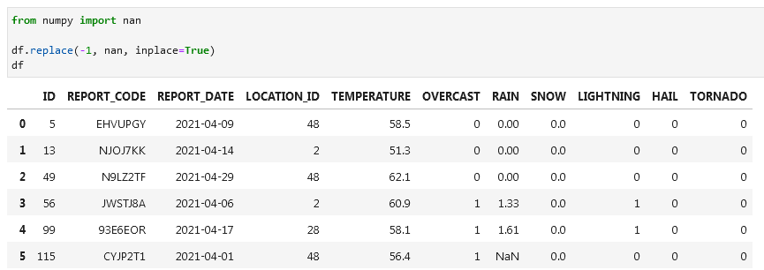

**SCIKIT LEARN Replace missing values with mean using SimpleImputer (imputer.fit, imputer.transform)**

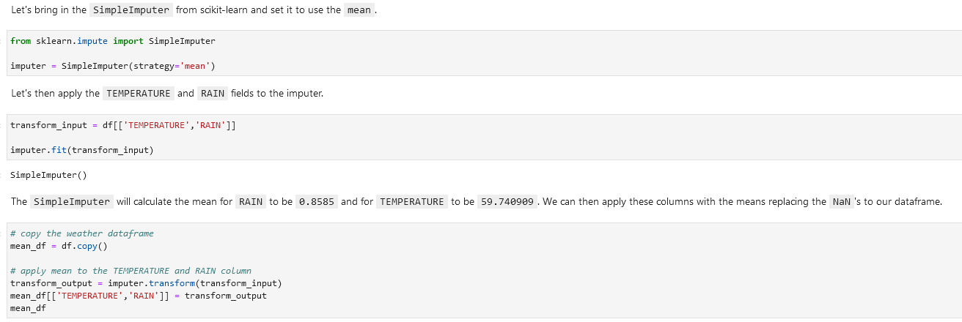

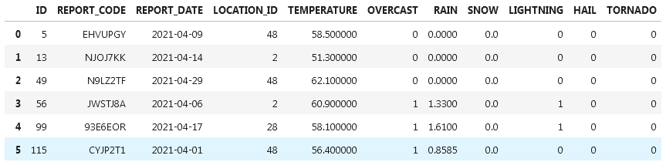

There are other options for the *strategy* parameter including 'mean', 'median', 'most_frequent', and 'constant'.

**SCIKIT LEARN Replace missing values with nearest neighbor using KNNImputer**



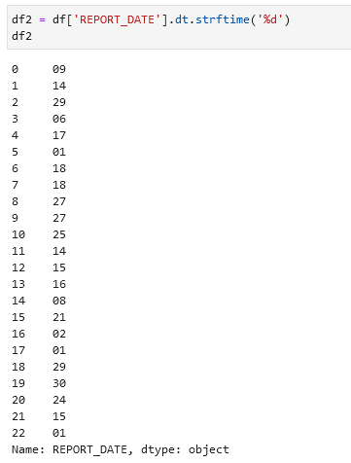 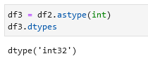

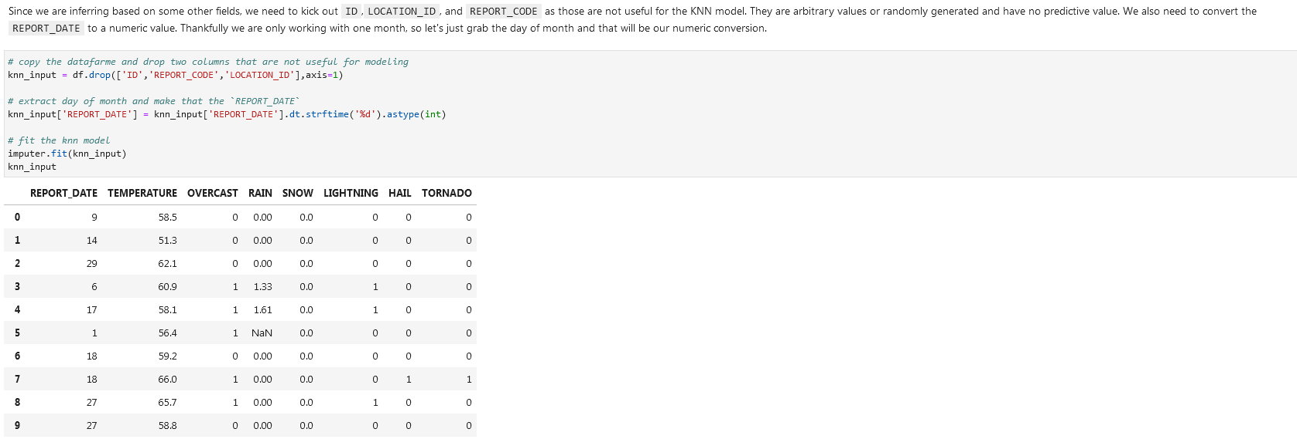

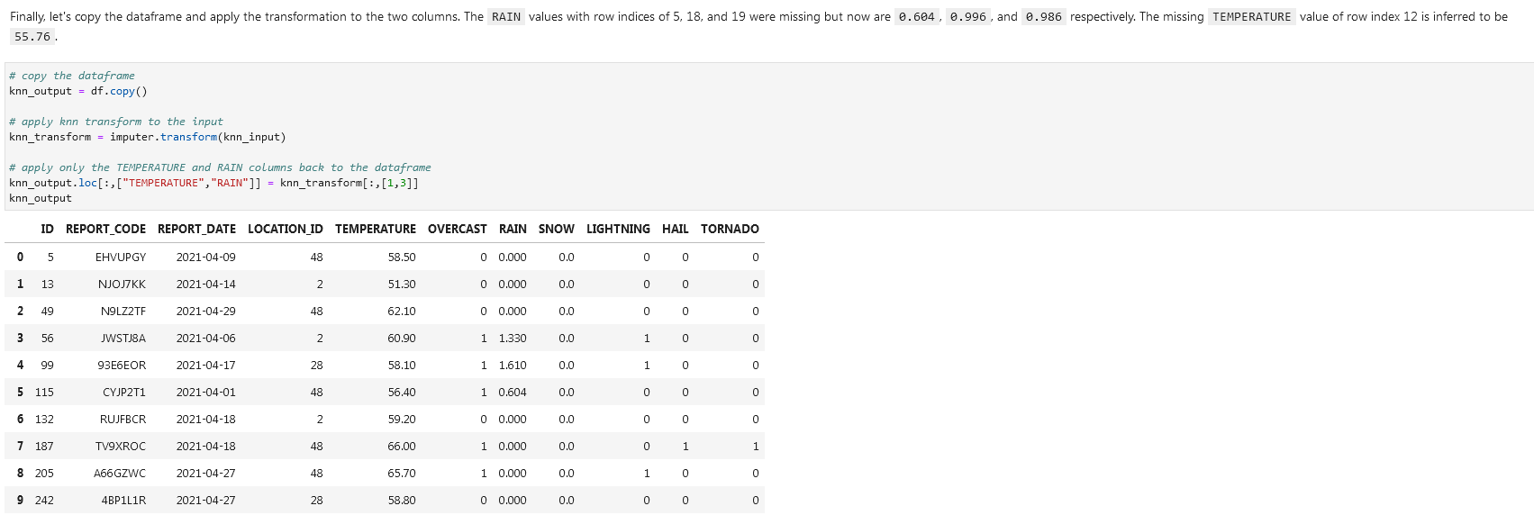

**Outliers**

We can use tools like *standard deviation (SD or* *σ [sigma])*  and *interquartile range*.

**Mean**

**Mean** mean = df.mean(axis=0)



**Standard deviation (SD, σ, sigma)**

**Standard deviation** sd = df.std(axis=0)

When calculating standard deviation with Pandas, it will be assumed to be a sample and therefore will calculate with 1 degree of freedom by default as shown in this formula:

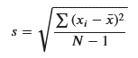

To get a sense of how standard deviations play a role in omitting outliers, consider the graphic below. 1 standard deviation away from the mean (average) will capture 68% of the expected data points assuming a normal distribution. 2 standard deviations will capture 95%, and 3 standard deviations will capture 99.7%. With a standard deviation, The lower the standard deviation, the more aggressively outliers will be removed.

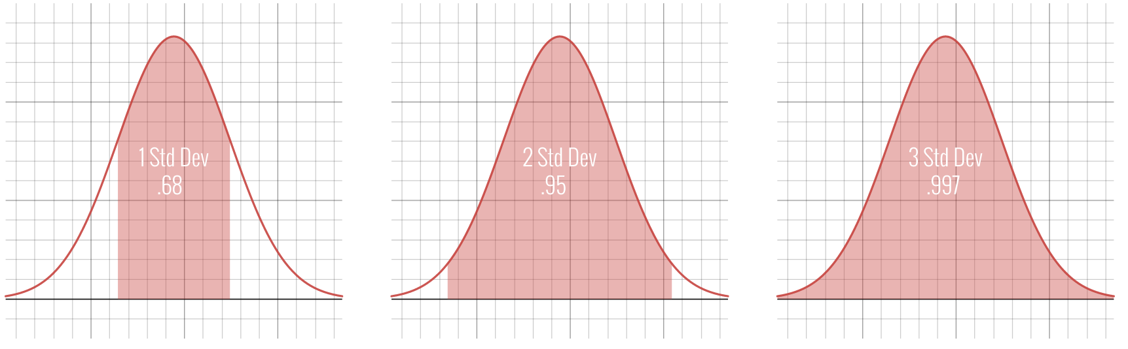

For smaller samples, cutting off at two standard deviations will be more common. This means we would declare any data on the tails outside those two standard deviations to be outliers and become candidate for removal.

Let's inspect the outliers outside two standard deviations. Multiply the standard deviation by 2 and subtract/add from the mean respectively to get the lower and upper bounds. Then we can compose a condition to identify the outliers by checking for weights less than or greater than these lower and upper bounds respectively.

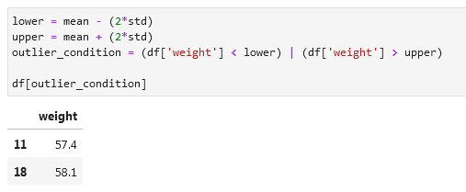

**Remove outliers that fall outside the two standard deviations**

df = df[(lower < df[‘column’]) & (df['column'] < upper)]

df

**PANDAS NUMPY Remove outliers that fall outside 2.25 standard deviations:**

Don’t forget the (axis=0)**[0]** for the mean and std.

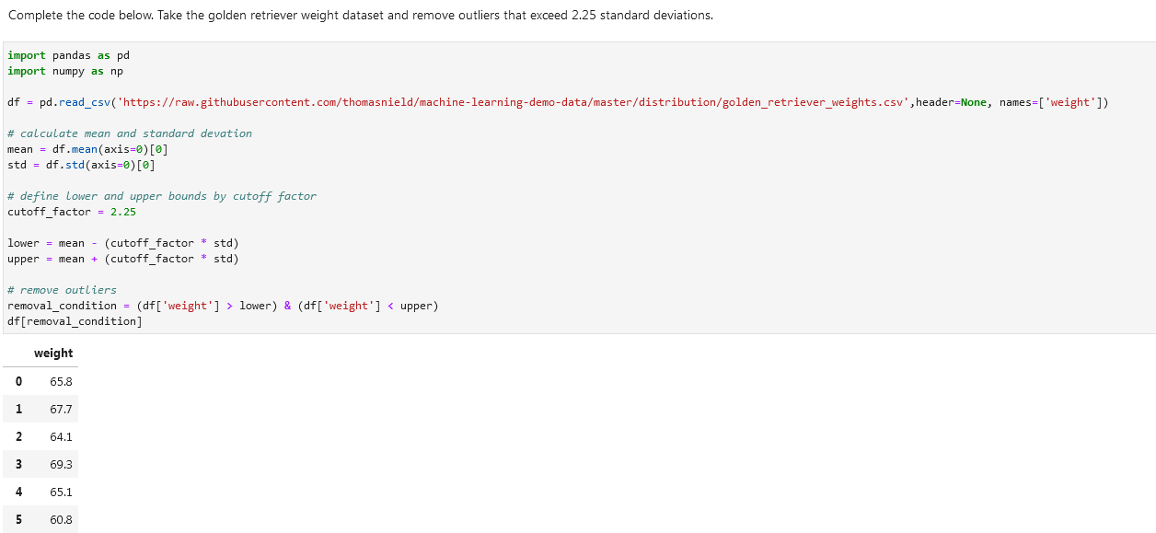

**Interquartile range outliers**

There is a lot of data that does not follow the nice bell curve shape of the normal distribution. Another way you can approach outliers in these cases is to use the Interquartile Range method, or IQR. This is the difference between the 75th and 25th percentile. When referring to the quarterly percentiles (0, 25, 50, 75, and 100). we refer to them as quartiles. A 50 percent quartile would be the middle-most value (the median), or the average of the two most-centered values.

Using the IQR, you will define a cutoff by a factor 𝑘 below or above the 25th and 75th percentile respectively. A common value for 𝑘 is 1.5, whereas a value of 3.0 would be used for more extreme cutoffs.

**Calculate percentile**

**NUMPY** In Python, we can use the **percentile() function** in NumPy to find a given percentile in a datastet.

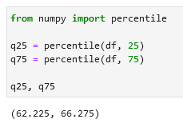

**Get IQR:**

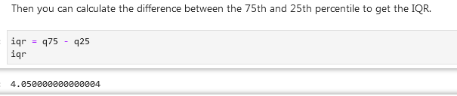

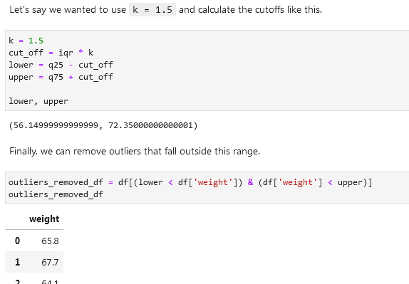

As you see above, the k value might be too generous for this dataset if we are looking to remove outliers. Maybe there are not extreme enough outliers in this dataset or this technique is just not warranted. But we can try to experiment lowering that k value to see how low the threshold must be before outliers removed. Below, I find a k value of 1.1 removes an outlier, with an index of 11 and weight of 54.

You can also use this technique on multidimensional data, by specifying an IQR policy for each field you want to target the removal of outliers.

**NUMPY Interquartile range outliers full walkthrough:**

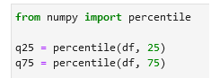



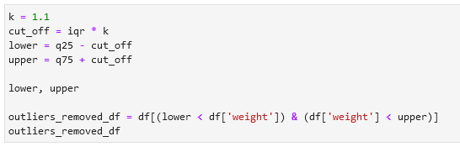

[**LocalOutlierFactor**](https://scikit-learn.org/stable/modules/generated/sklearn.neighbors.LocalOutlierFactor.html)

From a machine learning perspective, you can treat outliers as a classification. If they are far away from the rest of the datapoints in a multidimensional space, they can be detected as outliers. However, this becomes less reliable on higher dimensional problems due to curse of dimensionality. By leveraging logic that measures how far neighboring data points are, we can leverage the LocalOutlierFactor.

**SCIKIT LEARN Import LocalOutlierFactor** from sklearn.neighbors import LocalOutlierFactor

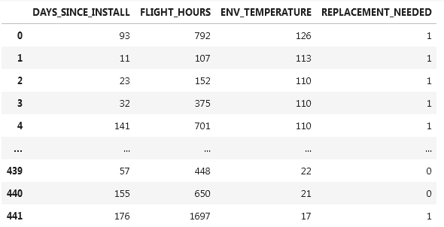

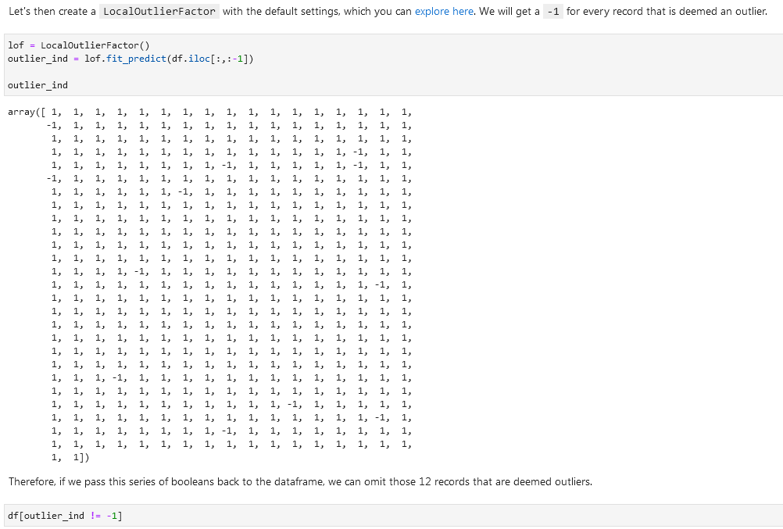

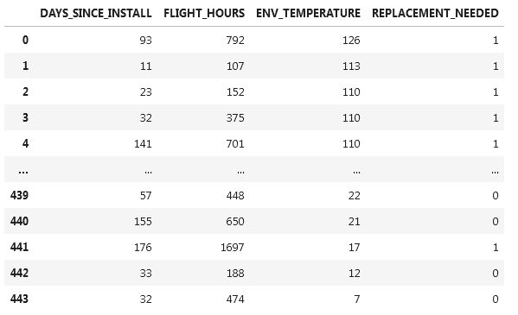

**Dates and times**

Check the data type of the date columns using *df.dtypes*. It might be *object* instead of *datetime64*. If a date-column has the right data type assigned then you can extract information from that column. Like day of the week and so on.

**Change data type of the date column (parse data)**  parsed_col = pd.to_datetime(df[‘column’])

parsed_col

**Extract day of week** parsed_col.dt.dayofweek

**Format dates columns as dates while importing csv:**



**Datetime conversion**

[Dataframe pandas conventions.](https://docs.python.org/3/library/datetime.html#strftime-and-strptime-behavior)

strftime() and strptime() are used to write a datetime to a formatting string, and parse a datetime from a formatted string respectively. The format codes come from the standard C conventions. Here are a few common ones, many of which we will use in this notebook. Refer to the link above to see all format codes.

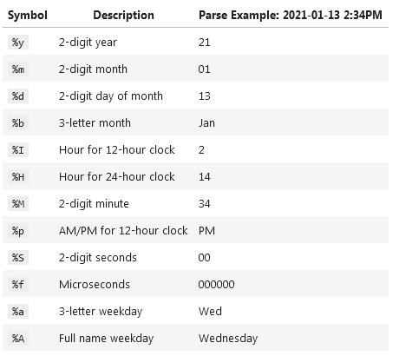

**ORDER_DATE_TM2 column has values like 22-Jan-22 4:08 PM. Correct them to a normal date type:**

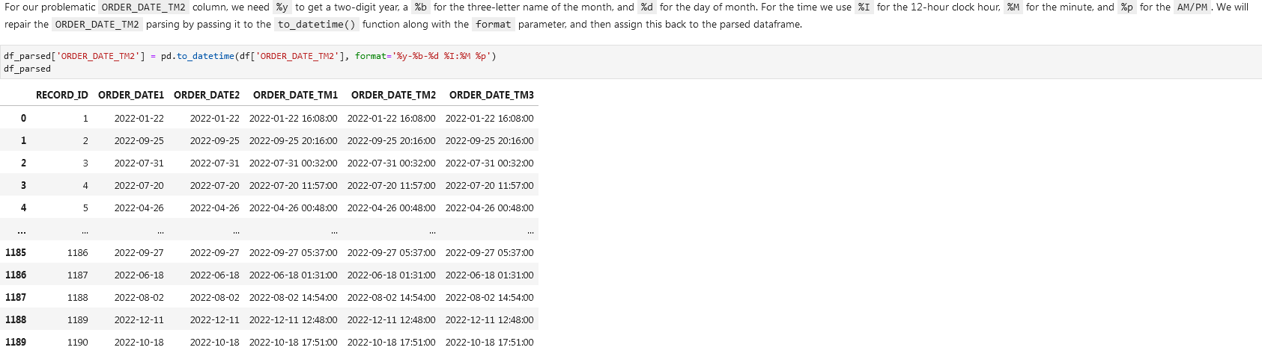



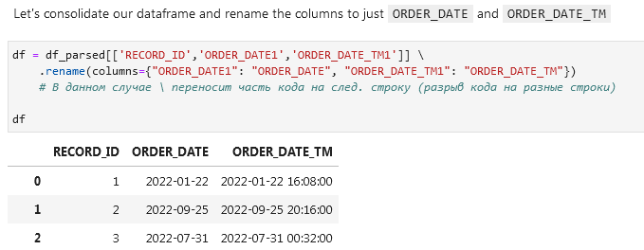

**Get all records where day of the week is Tuesday using dt.dayofweek**

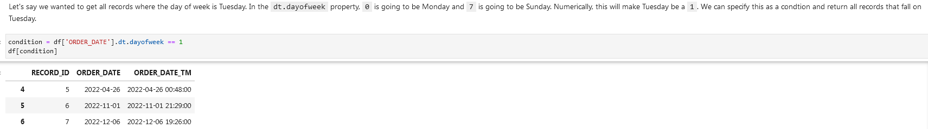

**Filter dates**

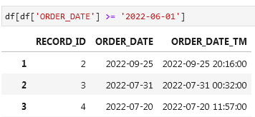

**Or filter between a specific date and time (option 1)**



And option 2

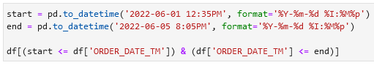

**Timezones**

**Pytz Library for timezones**

import pytz

pytz.common_timezones

**Look up a timezone in the pytz library**

tz = pytz.timezone('Europe/Amsterdam')

tz

<DstTzInfo 'Europe/Amsterdam' LMT+0:20:00 STD>

**Check if the column has timezone information using** [**.dt.tz**](https://pandas.pydata.org/docs/reference/api/pandas.Series.dt.tz.html)

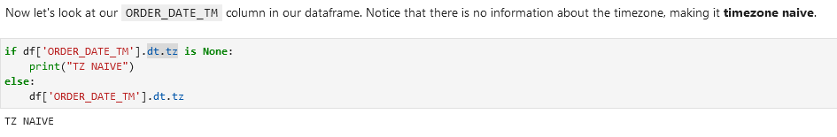

**Assign a timezone to a column**

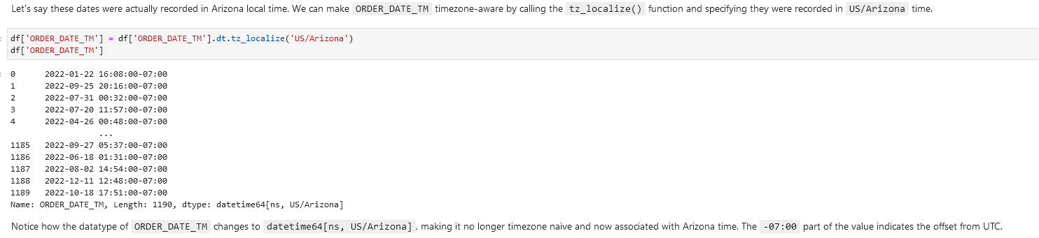

**Convert to a different timezone**

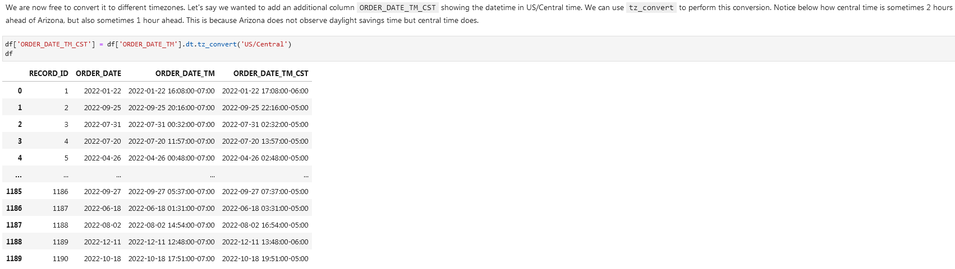

**Convert to UTC**



**Regular expressions (Python *re* library)**

[**re — Regular expression operations**](https://docs.python.org/3/library/re.html)

[**An introduction to regular expressions**](https://www.oreilly.com/content/an-introduction-to-regular-expressions/)

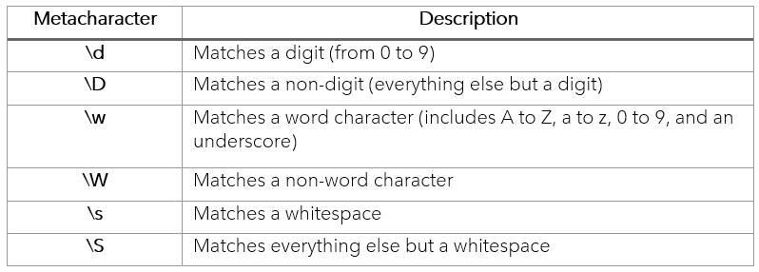

Regex quantifiers:

[**From:**](https://regex101.com/)

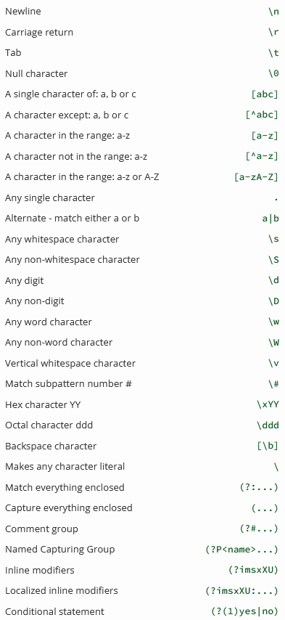

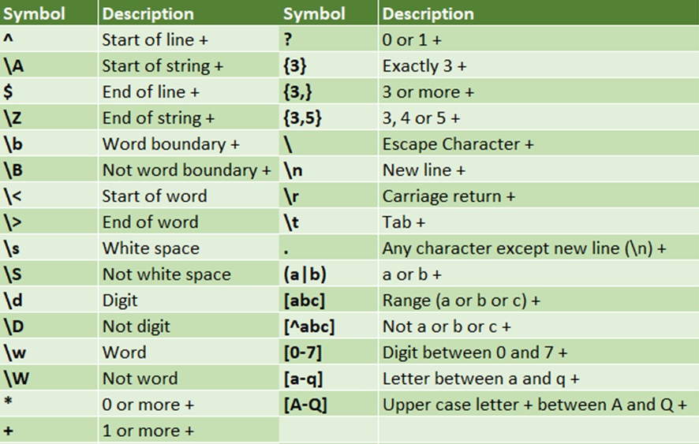

[From:](https://regexr.com/)

[Easiest way to remember Regular Expressions (Regex)](https://towardsdatascience.com/easiest-way-to-remember-regular-expressions-regex-178ba518bebd)

**Wrangling text / data cleaning**

These are the common string operations in Pandas we can use. Note that these typically accept a regular expression as a pattern, and we will cover this.

**Function Description *(functions in bold used below)***

count() Counts the number of instances in a pattern, e.g in the following list we have 3 occurrences of number 5:

**contains()** Returns a boolean True/False indicating whether a string contains a pattern

replace() Replaces the found patterns in a string with another specified string.

**fullmatch()** Determines if the entire string matches the pattern

split() Splits a string into separate strings using the pattern as the separator

extract() Finds all occurrences of a pattern and packages them into columns

**findall()** Finds all occurrences of a pattern and packages them into a list

**Fullmatch()**

Same but without coloring:

**Look for a value in a column.** Look up the value *outlook.com* using the *str.contains()* function in a column. Step 1:

**Step 2.** Before showing the values you need to decide on the *NaN* values. If you want them to be treated as *not outlook.com* then add *na=False*. If you don’t add this code you’ll get an error.

**Look for a value in a column alternative.** Using str.fullmatch()

Show values that don’t match our condition using == False:

Only include rows in a dataframe that have a valid phone number and an IP address:

Extract email domains from the email column using **str.findall()**

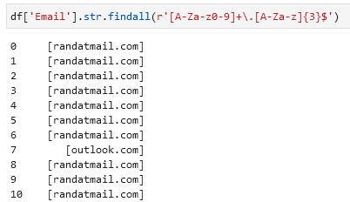

Gather unique domains from one column using str.join() and unique()

Show rows that have Eddy as first name:

Find unique values in a column:

**Replace values / replace matched values**

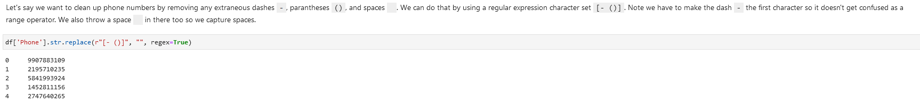

**Splitting columns / splitting text into different columns**

Splitting emails into two columns using str.split

When you use regular expression features like look-aheads, it opens up more powerful splitting capabilities based on surrounding characters.

Split data in a column into 3 columns (split one column into 3 columns):

Input column:



Code: -, are the symbols used for splitting.

**Plot data / Visualize data**

**MATPLOTLIB**

Plot every row in the column weight using .hist()

**Recursion (countdowns)**

Example 1:

Example 2 using if/else/return:

**→ Example 3 using a while loop looks like the best option from the 3 examples listed:**

**Fibonacci sequence**

In mathematics, the **Fibonacci sequence is a sequence in which each number is the sum of the two preceding ones**. Numbers that are part of the Fibonacci sequence are known as Fibonacci numbers, commonly denoted Fn . The sequence commonly starts from 0 and 1, although some authors start the sequence from 1 and 1 or sometimes (as did Fibonacci) from 1 and 2. Starting from 0 and 1, the first few values in the sequence are:

0, 1, 1, 2, 3, 5, 8, 13, 21, 34, 55, 89, 144.

**Generators (part of iterators / loops / iterations)**

Alternative to iter([1, 2, 3]) is a function with the yield keyword:

We can only yield inside a function.

Putting a yield anywhere in a function makes it return generators. Generators are iterators with some more features that we don't need to care about.

Actually we don't even need to use iter() and next() most of the time, but I think it's nice to know how for loops work.

If we have other lines of code between yield then they will be extracted this way:

[**Intertools**](https://docs.python.org/3/library/itertools.html) **— functions creating iterators for efficient looping.**

For example, itertools.count(1) does the same thing as our count().

**Iterable / iterator / for loops**

* An **iterable** is something that we can for loop over.
* An **iterator** is an iterable that remembers its position.
* For loops create an iterator of the iterable and call its __next__ method until it raises a StopIteration.
* Functions that contain yields return generators. Calling next() on a generator runs it to the next yield and gives us the value it yielded.
* [The itertools module](https://docs.python.org/3/library/itertools.html) contains many useful iterator-related things.

**Fill in a list with the help of a for loop / iteration** (add values to a blank list / fill in a blank list [])**:**

**List comprehensions**

List comprehensions are a **shorthand way** of creating and working with lists.

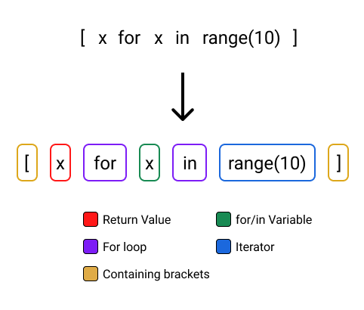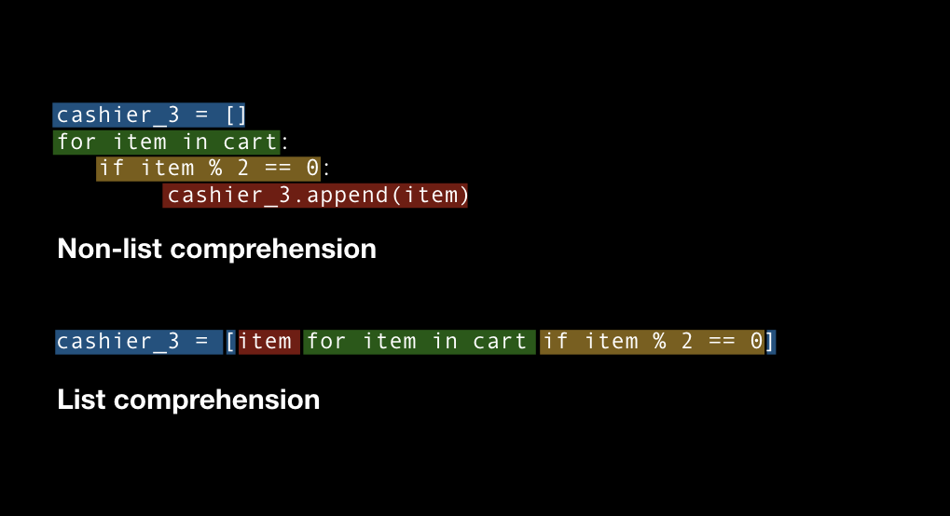

**Use list comprehension to shorten this: to this** (an example of a generator expression):

Another example:

This line can be read as follows: squares = [raise 'number' to the second power, for each 'number' in the range 1-10]

Another example:

Another example:

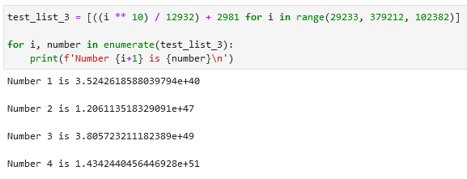

**Non-numeric comprehensions**

Example 1:

Example 2:

Example 3 with if and else:

**Generator expression**

**In function calls**

Example 1:

A ‘generator expression’ is this: (ord(symbol) for symbol in symbols).

Example 2:

**Example 3:**

Note that in the provided generator expression below values = () and not values = []. We’re not populating an empty list, but

**Cartesian product**

In set theory, the Cartesian product of two sets is the set of all possible ordered pairs where the first element comes from the first set and the second element comes from the second set.

For example, let's say we have two sets A = {1, 2} and B = {x, y}. The Cartesian product of A and B is {(1, x), (1, y), (2, x), (2, y)}. This means that for every element in set A, we can pair it with every element in set B to form a new ordered pair.

Example:

Using **format specifiers**, **replacement fields**, and .format():

'<10' and '<5' are called **format specifiers**. They tell the method to format the string to have a field width of 10 characters for color and 5 characters for size.

{:<10} and {:<5} are called **replacement fields**. They indicate where to insert the values of color and size into the formatted string.

**Example 2** with .format():

Here you have two occurrences of {}. They are placeholders. They are filled with information located in the parentheses in the .format() function.

**Named tuples**

from collections import namedtuple

Since Python 2.6, namedtuple can be used to build classes of objects that are just bundles of attributes with no custom methods, like a database record.

**Pick a random value**

from random import choice

**Python Data Model / Dunder Methods**

The "Python Data Model" refers to the set of protocols, conventions, and special methods that define how objects in Python behave and interact with each other. It is a conceptual framework that allows Python objects to implement certain operations and behaviors consistently.

The Python Data Model is defined in the Python language documentation and provides a way to customize the behavior of objects in Python by implementing special methods, also known as "magic methods" or "dunder methods" (short for "double underscore" methods). These special methods have predefined names and are used to define how objects respond to various built-in functions, operators, and syntax constructs.

By implementing the appropriate special methods, objects can emulate the behavior of built-in types, support iteration, comparison, arithmetic operations, context management, and more. Examples of these special methods include __init__ for object initialization, __len__ for retrieving the length of an object, __getitem__ for accessing elements using indexing, __str__ for generating a string representation of an object, and many others.

The Python Data Model provides a powerful and flexible way to define custom classes and objects that integrate seamlessly with the rest of the Python language and its features. It allows you to create objects that feel and behave like native Python types, enabling you to write expressive and intuitive code.

The Python Data Model is like a set of rules that define how objects in Python should behave. It tells objects how to respond to certain actions or operations.

Think of it as a guidebook for objects. Just like how people have different behaviors and can respond to various situations, objects in Python can also have different behaviors based on the methods they implement.

For example, if an object implements the __len__ method, it means it can be asked for its length using the len() function. If an object implements the __getitem__ method, it means it can be accessed using indexing or slicing, like a list or a string.

By following the rules of the Python Data Model and implementing the appropriate methods, objects can interact with other parts of the Python language more naturally. It allows you to create custom objects that work seamlessly with built-in functions, operators, and language constructs.

In simpler terms, the Python Data Model helps objects in Python play nicely with the rest of the language by defining how they should behave in certain situations.

**__init__ is called dunder init dunder.**

__init__ __str__ __repr__ __len__ __getitem__ __setitem__ _delitem__ _iter__ __next__ __eq__ __lt__ __gt__ __add__ __sub__ __mul__ __div__ __truediv__ __call__ __enter__ __exit__

**Overview of magic methods**

**Binary Operators**

|  |  |
| --- | --- |
| **Operator** | **Method** |
| + | `object.__add__(self, other)` |
| - | `object.__sub__(self, other)` |
| * | `object.__mul__(self, other)` |
| // | `object.__floordiv__(self, other)` |
| / | `object.__truediv__(self, other)` |
| % | `object.__mod__(self, other)` |
| ** | `object.__pow__(self, other[, module])` |
| << | `object.__lshift__(self, other)` |
| >> | `object.__rshift__(self, other)` |
| & | `object.__and__(self, other)` |
| ^ | `object.__xor__(self, other)` |
| | | `object.__or__(self, other)` |

**Extended assignments**

|  |  |
| --- | --- |
| **Operator** | **Method** |
| += | `object.__iadd__(self, other)` |
| -= | `object.__isub__(self, other)` |
| *= | `object.__imul__(self, other)` |
| /= | `object.__idiv__(self, other)` |
| //= | `object.__ifloordiv__(self, other)` |
| %= | `object.__imod__(self, other)` |
| **= | `object.__ipow__(self, other[, modulo])` |
| <<= | `object.__ilshift__(self, other)` |
| >>= | `object.__irshift__(self, other)` |
| &= | object.__iand__(self, other) |
| ^= | `object.__ixor__(self, other)` |
| |= | `object.__ior__(self, other)` |

3 examples:

In each case, the extended assignment operator modifies the value of the left-hand side operand (x in the examples) using the specified operation with the right-hand side operand (y in the examples). The result is then assigned back to the left-hand side operand.

**Unary operators:**

|  |  |
| --- | --- |
| **Operator** | **Method** |
| - | `object.__neg__(self)` |
| + | `object.__pos__(self)` |
| abs() | `object.__abs__(self)` |
| ~ | `object.__invert__(self)` |
| complex() | `object.__complex__(self)` |
| int() | `object.__int__(self)` |
| long() | `object.__long__(self)` |
| float() | `object.__float__(self)` |
| oct() | `object.__oct__(self)` |
| hex() | `object.__hex__(self)` |

Examples:

**Comparison operators:**

|  |  |
| --- | --- |
| **Operator** | **Method** |
| < | `object.__lt__(self, other)` |
| <= | `object.__le__(self, other)` |
| == | `object.__eq__(self, other)` |
| != | `object.__ne__(self, other)` |
| >= | `object.__ge__(self, other)` |
| > | `object.__gt__(self, other)` |

Examples:

S

**Example class:**

__repr__ allows to access the object directly using its name like here vector1:

__abs__:

__bool__:

__add__:

__mul__:

__call__:

The __call__ method enables Python programmers to write classes where the instances behave like functions. Both functions and the instances of such classes are called **callables**.

**Added on 01.06.2023:**

**Example without Python data model:**

**Class 1:**

Accessing the class:

**Class 2 with data model (note the return instead of print):**

Accessing the class:

**Functions**

reversed()

**First-class objects**

Functions in Python are **first-class objects**.

Programming language theorists define a **first-class object** as a program entity that can be:

* Created at runtime
* Assigned to a variable or element in a data structure
* Passed as an argument to a function
* Returned as the result of a function

Integers, strings, and dictionaries are other examples of first-class objects in Python — nothing fancy here.

**Difference between return and print**

In Python, return and print serve different purposes.

* return is used within a function to specify the value that the function should evaluate to and return to the caller. When a function encounters a **return** statement, it immediately exits the function and returns the specified value to the caller. The returned value can be assigned to a variable or used in further computations.
* print is used to display output on the console or terminal. It sends the specified values or expressions to the standard output (by default, the console) for display. **print** is typically used for debugging, displaying information, or providing output to the user.

To summarize:

* Use return when you want a function to compute a value and provide it as a result to the caller.
* Use print when you want to display information or output to the console or terminal.

In the context of your __repr__ method, you should use return instead of print to specify the string representation of the object that will be returned when calling repr() on the object.

**Find values that begin o**

**r end with a specific value**

Use startswith() or endswith(). Example on the left is preferred (PEP 8 advice) over this (less error prone):



**Comparing object types**

Use isinstance for that:

Checking something using in:

In this case good is indeed in the text good bye and that is why the result is True.

**replace()**

To replace values with other values use this function (like CTRL + H in Excel):

**str.maketrans() и str.translate()**

**Replace a symbol / a list of symbols with a symbol / a list of symbols.**

Используй str.maketrans(), чтобы указать замену буквы/символа. Например внизу *ё* заменяется *е* или во втором примере *a* это *1*, *e* это *2* и так далее. После этого используй str.translate(), чтобы провести замену.

Example 1: Example 2:

**Exceptions / functions and exceptions**

They are triggered automatically on errors, and they can be triggered and intercepted by your code.

Examples:

1. try/
   1. except Catch and recover from exceptions raised by Python or by you
   2. finally Perform cleanup actions, whether exceptions occur or not
2. raise Trigger an exception manually in your code
3. assert Conditionally trigger an exception in your code
4. with/as Implement context managers

**try/except *(try except, try-except)***

**Example 1:**

It illustrates an option **how to** **cope with errors**. We get a NameError if we run the current code. This can be addressed by using try except.

**Example 2:**

Function that uses a try except:

**Example 3:**

**try/finally**

**Example:**

If a finally clause is included in a try, Python will always run its block of statements “on the way out” of the try statement, whether an exception occurred while the try block was running or not. In its general form, it is:

try:

statements # Run this action first

finally:

statements # Always run this code on the way out

**finally can be seen in the example above (try/except).**

**raise**

You can also raise an error inside a function. In the example below an error is raised when an input value is incorrect:

**with/as Context Managers:**

This statement is designed to work with context manager objects, which support a new method-based protocol, similar in spirit to the way that iteration tools work with methods of the iteration protocol.

**PEP 8**

<https://peps.python.org/pep-0008/>

* Use **4 spaces** or a **tab** consisted of 4 spaces
* **Line length** should be 79 for characters and 72 for comments. Alternative is 99 characters. Editors have a setting that shows a vertical line that helps you keep track of the lines.
* Use **blank lines** to break up your code into meaningful blocks. Two can be used in longer programs.
* **Name** variables and program files using only **lowercase** letters, underscores, and numbers.

**Import statements:**

Names of classes can be on the same line:



Imports should always be placed at the top of the file. When you are working on a longer program, you might have an idea that requires an import statement. You might write the import statement in the code block you are working on to see if your idea works. If you end up keeping the import, make sure you move the import statement to the top of the file. This lets anyone who works with your program see what modules are required for the program to work.

Your import statements should be in a predictable order:

* The first imports should be standard Python modules such as sys, os, and math.
* The second set of imports should be "third-party" libraries. These are libraries that are written and maintained by independent programmers, which are not part of the official Python language.

**Errors**

Use %%script false –no-raise-error at the beginning of a code if you don’t want to get an error message / evade an error. Example:

**Modules / libraries**

**time module**

**Delay execution time using time.sleep()**

The first line of code will print right away but the second print-statement will execute with a 10 seconds delay:

**itertools module**

Create an itertator that produces the Cartesian product of the input iterables OR simply generate all possible combinations of the elements from the input:

**random module**

**.choices()**

Create a generated list with the values you specified *x* times (k=) long using .choices():



Return 1 random letter from the provided input:

Return 1 random number from the provided list:

You can also use the *weight* parameter:

**.sample()**

Using .sample() you can **generate a sample from your data** you already have:

You can also use counts:

(this means that value *1* should occur *10* times and value *5* occurs *1* time: 1, 1, 1, 1, 1, 1, 1, 1, 1, 1, 5)

For numbers you can use range() (5 is k=5):

**.randrange()**

Using .randrange() you can generate a number between the two given numbers:

**collections module**

The Counter class returns a ‘dictionary’ with your given values as keys and the number of these values occurred as values:

Use .most_common() to list the most common elements:

You can also add a number in the parenthesis, e.g. .most_common(3), and that will return top-3 most common elements:

**Faker module**

Install and import the module first:

If you are looking for data for a specific country you can specify that right away:



Use commands like .name(), .address() to generate fake data:

**pandas module / library**

**DataFrame**

In pandas, a DataFrame is a two-dimensional tabular data structure, similar to a table in a relational database or a spreadsheet. It consists of rows and columns, where each column can have a different data type (e.g., numbers, strings, dates) and each row represents a unique record or observation.

You can think of a DataFrame as a collection of Series objects (one-dimensional labeled arrays) aligned along a common index. Each column in the DataFrame represents a Series, and together they form the table-like structure.

Pandas provides a rich set of functions and methods to manipulate, analyze, and visualize the data in a DataFrame. You can perform operations like filtering rows, selecting specific columns, aggregating data, merging/joining tables, and much more. It's a powerful tool for data manipulation and analysis in Python.

**Create a dataframe using pd.DataFrame({}):**

Access parts of the dataframe:

**functools module**

**Function reduce**

Apply a function of two arguments cumulatively to the items of a sequence, from left to right, so as to reduce the sequence to a single value. For example, reduce(lambda x, y: x+y, [1, 2, 3, 4, 5]) calculates ((((1+2)+3)+4)+5). If initial is present, it is placed before the items of the sequence in the calculation, and serves as a default when the sequence is empty.

Example 1 using lambda: Example 2:

This example can be easily turned into example 2 by changing the + sign into *.

**tqdm module**

Use the tqdm() function to **add a progress bar** to visualize the iteration progress.

In the exampe below the function takes an iterable *pages* as an argument and wraps the for loop. Each iteration of the loop updates the progress bar to indicate the progress.

**warnings module**

**warnings.warn**

Use function warnings.warn to **generate a warning message**:

In the example below a ***DepreciationWarning*** message is generated. A *DepreciationWarning* indicates that a Python’s feature or functionality is depreciated and will be removed in the future, and you should probably think of replacing it with something newer. Despite the warning, the code will be executed.

**warnings.simplefilter**

Use function warnings.simplefilter to modify the behavior of how warnings of a specific category are treated. This function has several *actions* like default, ignore, error, etc.

This example shows the functionality of the error *action*. This warning message:

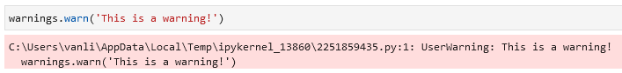

Transforms into an error message:

By setting the filter to error, the code enforces a stricter behavior regarding ***UserWarning*** and treats them as errors that need to be addressed. This can be useful when you want to ensure that certain warnings are not ignored and are treated as significant issues in your code.

Use ignore to ignore all errors and warnings:

Use reset to reset all errors and warnings:

**warnings.catch_warnings()**

**\*args and **kwargs**

In the function below my_arg accepts only 1 value as input, *args accept any other value that follows, and **kwargs accept all subsequent values in the ‘*dictionary’* style. It is important to follow this structure when writing the function as well as when running the function — values should also be in this order. Otherwise you’ll get an error.

Example 1: Example 2: Example 3: Example 4:

**if, elif, and else in functions**

Encapsulation can be achieved by giving default values (in the example below summer="Play Volleyball", winter="Go snowboarding"), and when running the function you give your own default values:

**Functions**

**all() function**

all() takes an iterable as its argument and **returns True if all the elements in the iterable are considered truthy** (i.e., non-zero, non-empty, or *True*), and *False* otherwise. It can be used to **check if all the elements in a collection satisfy a certain condition**.

It is also good for memory optimization because it stops when the condition is not met.

Examples:

